Environment and Horticultural Plants
Charles W. Marr
Department of Horticulture
Kansas State University
Horticultural plants grow in response to their environment. Plants are cultivated from many areas of the world. Each has a different set of environmental conditions to which the plant has become adapted. Much of horticulture is concerned with modifying plant environments to enhance growth. This chapter covers several of the major environmental factors that influence plant growth and the influence of climatic variations on horticultural plants.

Climate
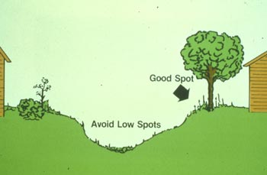
Climate is the combined effects of temperature, light and elements of moisture such as clouds, rain, hail, snow and wind. Climate usually refers to long term weather patterns in a region or as it is often called, macroclimate.
Temperatures are greatest at the earth's surface near the equator where the sun's rays strike directly. As you move north or south from the equator it gradually becomes cooler. Altitude also influences temperatures with cooler temperatures occurring at higher altitudes. Climatic patterns are also altered by large bodies of water nearby. More energy is required to raise the temperature of water than air. Water releases this energy as it cools. Thus, water acts as a buffer for nearby land areas and reduces temperature extremes. Inland areas of the U.S. lack the protection of large bodies of water and experience high summer temperatures and cold, arctic fronts in the winter.
Mountains also alter climate by blocking natural wind and moisture movement. Several areas of the Pacific northwest have wet, rainy areas on the ocean side of mountains and dry areas on the inland side. Vegetation also influences climate. Forested areas have a higher relative humidity. This and additional evaporation of water from tree leaves has a cooling effect.
Human activities also influence climate. Large reservoirs have been constructed in many areas. Metropolitan areas are warmed by combustion used in heating and by buildings, streets and other structures absorbing and holding heat. Dust, environmental pollutants and smoke also alter the climate. A concern in many areas of the eastern U.S., Canada and Europe is acid rain, formed as rainfall absorbs acidic materials from air pollution. All of these macroclimate differences have an effect on plant species growing in an area and may cause climatic variations.
Microclimate refers to the climate in a small area such as near a plant or in a yard or garden. Cold air is heavier than warm air and tends to settle in low areas creating a temperature inversion. Temperatures in low areas can be several degrees cooler than surrounding hillsides. These pockets of cold air are called frost pockets. Orchards are generally located on hillsides to avoid areas likely to damage flowers in early spring. Selecting a home site on a sloping area can also avoid low temperature injury to ornamentals in the fall and spring. Carefully locating plants around a home can take advantage of microclimate differences. Shade loving plants can be grown on north or east exposures and plants can be protected from the blast of west or north winds by planting them on the protected side of the house. Horticulturists need to be aware of the influence of climate in a particular area, both macroclimates and microclimates. Selection and growth of horticultural plants is directly influenced by climate.

Temperature
Temperature largely determines what can be grown in a particular area. Photosynthesis (the conversion of solar energy for use by the plant) and respiration (the using of stored energy compounds in the plant for growth and development) are regulated by temperature. With most biological reactions each 10°C (18°F) increase in temperature doubles the rate of the reaction. Therefore, we expect the rate of growth at 68°F to be twice as fast as at 50°F. This relationship is known as Q10. Each plant has an optimum temperature for growth and development . There is a maximum temperature where plant growth stops and permanent injury to the plant occurs. Likewise, there is a minimum temperature where plant growth stops and freezing or chilling injury occurs.
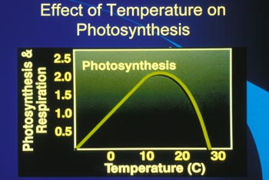
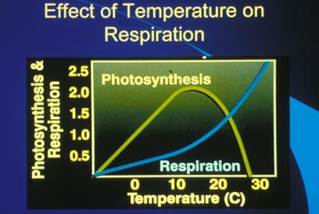
Cool Season Plants
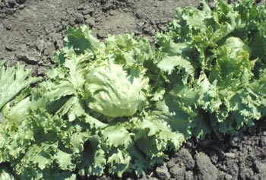
Depending on their area of native adaptation, plants prefer cooler or warmer temperatures. Cool loving plants tolerate temperatures slightly below the 32°F. Growth is poor at warmer temperatures. Examples of cool season plants include vegetables (cabbage, broccoli, lettuce, radishes, peas), flowers (crocus, daffodil, tulips, violets), fruits (apples, pears, plums, American grapes) and shrubs (forsythia, lilac, spirea, honeysuckle). Cool season plants prefer average daily temperatures below 70°F. Premature seed stalk formation or bolting of biennial vegetables is a problem for cool season crops. Cool temperatures following planting compresses their natural growth cycle and seed stalks often form later in the season.
Warm Season Plants
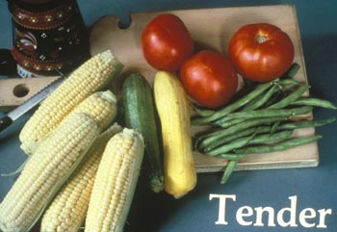
Some plants prefer temperatures above 70°F and are usually injured by freezing temperatures. Sometimes these plants are called nonhardy or tender plants, while those that can withstand freezing temperatures are called hardy plants. Examples of warm season crops are vegetables (beans, tomatoes, sweet corn, melons), flowers (roses, lilies tropical foliage plants) and fruits (peaches, apricots, sweet cherries).
Freezing Injury
When the temperature drops below 32°F there is a chance of injury to some plants. This is frequently called frost injury. Frost is ice formation on a surface while plant injury occurs only when ice forms within the plant. Generally, the period just before dawn is the time when the temperature reaches the lowest point and freezing injury occurs. Freezing injury results in an immediate water soaked, blackened appearance that quickly turns brown and dies. It is a common horticultural practice to cover plants with insulating materials or sprinkle plants with water to prevent freezing temperatures from occurring within the plant. While water from a sprinkler may feel very cold it has some heat energy that is passed on to the plant. There is a lot of current research on treatments to allow plants to be exposed to lower temperatures without injury and to understand the mechanism of freezing injury to plant tissues.
Chilling Injury
Injury can occur to warm season plants or products exposed to low temperatures. This low temperature injury is called chilling injury and results from a malfunction in the normal plant growth processes rather than the freezing of water within the plant. Crops such as cucumbers, tomatoes, tropical fruits and most tropical foliage plants, are subject to chilling injury. The development of chilling injury usually results in rapid respiration, the development of rots and molds, bitter or "off flavors" and abnormal colors. Chilling injury may occur at temperatures below 45-50°F in many plants or products. You see it when a banana turns black after being placed in a refrigerator.
Rest Period
There are periods when a plant or seed does not grow despite favorable conditions. These periods are called rest periods. They usually coincide with the natural period of dormancy for perennial plants during the winter. During this time deciduous plants lose their leaves and herbaceous plants are frozen back to the ground. Buds of woody plants do not grow due to physiological and biochemical processes. Following a period of cold, the buds break (end) their rest period and continue growth. The temperature and hours needed to break dormancy has been determined for many plants. Fruit varieties are grouped by their requirement of hours at or below a critical temperature (usually 40°F) to break the rest period. Desirable environmental conditions are necessary to resume growth following the breaking of the rest period.
Many temperate plants produce seeds with a natural rest period following ripening. This rest period can only be broken by exposure to cold temperatures for a period of time. This process is called stratification. We can artificially stratify seeds by storing them in a moist medium such as peat moss or sand at near freezing temperatures (usually 40°F) for a number of weeks. This breaks the normal rest period and allows the seeds to germinate uniformly.
Woody Plant Survival
An example of hardiness has already been provided for annual plants tolerant to low temperatures. Woody plants can also tolerate low temperatures to varying degrees. Native plants have, through the years, adapted to withstand low temperatures and are said to be hardy to the area where they evolved. The level of low winter temperatures that a particular type of plant can withstand has been determined for most woody plant species. The United States is divided into areas called plant hardiness zones. The zones are numbered 1-10 from colder to warmer areas. This map was developed by the US Department of Agriculture.
Woody ornamental plants survive average normal low winter temperatures in these areas and plants can be characterized by their adaptation to these climatic zones. It must be remembered that these zones are based on the average of all of the lowest winter temperatures recorded over a 50 year period. In certain extreme years, such as in January 1994, severe damage to plant material occurred because the temperatures were so much colder than normally would be expected. Damage also frequently occurs to normally hardy plants when an unusually early frost or freeze hits plants before they are fully dormant or in the spring after they have begun to lose dormancy.
Modifying Temperatures
Much of horticulture is involved in altering the environment to improve plant growth. Areas of horticultural production have developed in areas where natural protection from temperature extremes exists. Such protection is provided by large bodies of water such as the western area of Michigan and the western areas of New York bordering the Great Lakes. Buildings, streets, etc. in large cities absorb heat and reradiate it at night providing several degrees of warmth against the first freezing temperatures of the fall.
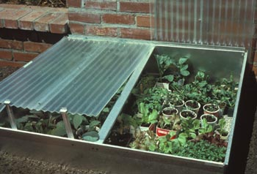
Growing plants in a managed environment like a greenhouse was developed to provide a favorable temperature during adverse periods. There are other examples of treatments horticulturists use to modify temperature. These including the use of mulches. Black or clear plastic absorbs heat and transfers it to the soil encouraging earlier plant growth in the spring. Hotcaps or hot-tents - paper or plastic covers also serve as miniature greenhouses to modify the microclimate around transplants in the spring.
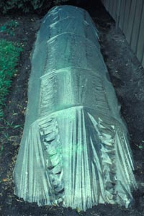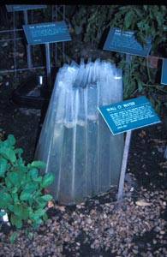
Sheets of fiberglass or porous plastic are frequently placed over rows of plants to warm them in the spring. This type of structure is called a cloche (pronounced klosh) or row cover. Another example or a specialized plant growing structure is a hotbed or coldframe used to start seedling plants. Water mist is frequently used as a means of reducing freezing temperature injury. The protection provided by water mist is based on the principle that as water freezes it gives off heat. Thus, as the water freezes it gives off enough heat to protect plants for a few degrees. Other examples of frost protection include smudge pots, stoves and air turbulators used in orchards to force warmer air around plant surfaces. Horticulturists continue to study ways to understand the mechanisms of temperature injury, ways of improving the adaptation of plants to temperature extremes and ways of altering the temperature around horticultural plants to improve their growth.

Water
A brief drive through the desert, failure to water a pot of flowers, or wilted lettuce on a salad bar reminds us of the importance of water for plant growth and development. Just as with temperature extremes, plants have adapted to grow in areas of low water availability. Thick, fleshy leaves, layers of wax, specialized structures for water storage and other mechanisms help plants survive in areas of limited water. Such plants are called xerophitic.
Water in the Plant and Soil
Water constitutes an important part of plants. Living plants need a constant flow of water from the roots to leaves to continue their life processes. Water in plant cells provides pressure on cell walls, called turgor pressure, keeping the plant rigid. Water is an important constituent of photosynthesis. Water flows from the root, up the stem and into the leaves in specialized conducting cells called xylem cells. Movement of nutrients and other constituents flow in water in the plant as well. Pressure from water in the cell enables cells to enlarge and expand. Water not used by plant cells evaporates and moves out of the leaf through small pores or openings in the leaf surface called stomata. Evaporation of water from the leaf is called transpiration. Evaporation of water from the leaf has a cooling effect and reduces temperatures in the surrounding environment.
Water moves into root cells from the soil. Soils differ in the amount of water that they can hold. Sandy soils hold less water than loam or clay soils. Water available to a plant from a particular soil is called the soil water potential. Some water is held so tightly by the soil that the plant cannot extract it. Water that the plant can extract from the soil is called available water. The root system develops in the soil to obtain water for the plant. Sudden flooding of the soil cuts off oxygen to the root system and causes root death. Plants in flooded locations can die quickly from such injury. Too much water can be as serious a problem as not enough water. For this reason, a greenhouse manager must carefully monitor the water level in containers to provide the proper amount of water to meet the crop's needs. In field situations, drainage tiles or pipes are often installed to allow excess water to be removed. Water is lost from soils by evaporation from the soil surface. Evaporation of water from soil combined with loss of water through the plant (transpiration) is referred to by the combined word evapotranspiration, or loss of water by plant and soil combined.
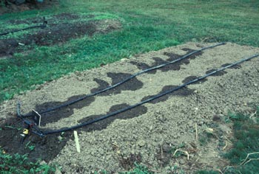
Applying Water to Plants
Horticultural production has developed where water is abundant. Applying water to supplement rainfall is a standard practice for many horticultural crops. Irrigation should replace water removed by plants. Considerations in irrigation amounts and frequency depend on the needs of the crop, the depth of roots and the ability of the soil to absorb water. A certain portion of the water is lost to evaporation before it reaches the soil. On a windy day a sprinkler system putting out a fine mist may lose 25-30% of the water applied before it reaches the soil. Drip or trickle irrigation allows small amounts of water to be applied frequently to a portion of the root zone. This reduces the amount of water needed to grow a crop.
Effects of Limited Water Availability
For many horticultural plants there is a period of critical water need when water may not be available. For most plants this is during the period of flowering and fruit development. A symptom of water need is wilting of the foliage. Plants are affected by stress before the external symptom of wilting occurs. Emphasis on water levels necessary to support plant growth and scheduling irrigation to minimize water use is important. Water needs can be predicted from climatic factors such as temperature, humidity, wind and solar radiation combined with particular characteristics of the crop and soil type. Microcomputers assemble various weather factors and develop predictions and schedules for adding supplemental water. Fluctuations in water available can cause sudden splitting of cherries, tomatoes and cabbage. Uniform water supplies are necessary to prevent these problems.

Light
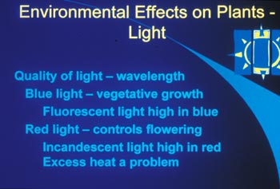
Light is essential for photosynthesis. Green plants are the original solar collectors. They transfer energy from the sun to a usable form of energy for the plant. Light varies in intensity, quality and duration or photoperiod.
Intensity
The intensity or amount of light available has a direct influence on the amount of photo-synthesis that can occur. Some plants have adapted to growing in areas of low light availability such as a jungle floor. This is why tropical foliage plants grow well in limited indoor light. Grasses are native to the open plains and require high light intensity for growth. When light intensity is lowered, the rate of photosynthesis is reduced. When the level of photosynthesis equals respiration, it is referred to as the compensation point. Below compensation point growth ceases.
Sudden exposure to high light intensity can cause leaf scorch or sunburning. The symptoms are large, brown, dead areas on leaves. Plants growing in low light have a thinner layer of wax on leaf surfaces. This helps the leaf to capture more light. However, moving it suddenly into bright light results in rapid water loss. High light intensity can also cause fading of flowers, especially in hot summer weather. An area of special interest to the greenhouse industry is the use of high intensity lights to supplement natural light and to extend the photoperiod. Crops of high value make the expense of installing and operating high intensity supplemental lights economical.
Light Quality
Light quality refers to the "color" of the light or the portion of the light spectrum. The biochemical constituents of chlorophyll, the compound responsible for photosynthesis, absorb only light from particular portions of the light spectrum. Artificial lights supply light of particular portions of the spectrum. Light absorbed by plants is from the blue-violet and orange-red parts of the spectrum. Specialized lamps have been developed to provide light rich in wavelengths from this part of the spectrum. These lamps have the additional benefit of creating dark green foliage and a deep, intense flower color. Excellent plant growth can be achieved with ordinary fluorescent bulbs. Other portions of the spectrum such as ultraviolet light are important in the coloration of some fruits and the development of autumn color in leaves.
Photoperiod
The daily duration of light is important for many plants. The lengths of light and dark period in a 24 hour cycle influences the blooming response of many plants. Some plants form flowers with shorter day lengths (usually less than 12 hours). These plants are called short-day plants and grow without blooming during days with long photoperiods. Other plants are long-day plants and form flowers during longer days (usually 14 hours or longer). The most common examples of short-day plants are poinsettia and chrysanthemum that flower during the shorter days of autumn. Examples of long-day plants include many of our summer flowering annuals. Greenhouse producers must know the photoperiod requirements of plants and alter the day length to induce flowering at the proper time. Days are shortened by covering greenhouse benches with dark shade cloth. Day length is extended by artificial lights over the benches. Many plants are day neutral. These plants are not influenced by the number of hours of light. A common example is the tomato that blooms and fruits with favorable temperatures during any day length.
While we speak of day length, it is important to remember that it is really the length of the dark period that makes the difference. To keep a shortday plant from flowering naturally in the fall we only have to break up the dark period into two shorter segments. For some plants as little as five minutes of light in the middle of the night will keep it from flowering.

Relative Humidity and Wind
Relative humidity is the amount of water vapor in the air. It is closely related to temperature. As the temperature goes down, relative humidity goes up. Relative humidity is measured as a percent. When it reaches 100% we have rain, snow, fog, or sleet. This is why it rains as a cold front goes through.
As the relative humidity drops, evaporation increases. Plants leaves give off more water at 40% than 80% relative humidity. This water loss increases if the wind is blowing. Tropical foliage plants are native of humid, jungle environments and often suffer in the dry, indoor air in winter. Grouping plants together and placing plants on a layer of pebbles in standing water helps increase relative humidity. Lowering the interior temperature of homes is beneficial in reducing some of the low humidity problems with plants.
Humidity is often related to the development of certain plant diseases. Warm, damp conditions are ideal to encourage the growth of fungi. Many fungal spores must have water to begin growing. Damping off is a common problem for seedlings. It results from fungi rotting small plants at the soil line. Increasing air circulation to lower humidity and reducing watering can generally stop the problem.
Wind is a problem with plant production in some areas. In addition to blowing away valuable soil, wind can also cause injury to tender plant stems by sandblasting the stems at the soil line. New transplants and newly planted trees are often shaded as a protection from hot sun and wind. In many areas of the Great Plains of the U.S., the planting of rows of trees in a windbreak protects homes and animals. Strong winds in storms damage many trees and shrubs each year. Wind damage is especially severe when it is in combination with ice. The plant species is also important. Trees such as silver maple, Siberian elm and willow are more frequently injured by wind than oak, walnut and sugar maple.

Interrelationships
Plants are influenced simultaneously by all segments of their environment. As light intensity increases, temperature generally increases with a corresponding increase in photosynthesis and water loss by the plant. Many times horticulturists must alter one environmental factor as another changes. When light levels are reduced, a greenhouse manager will often lower temperatures. Without the temperature reduction, plants become tall and spindly. The reduction in temperature limits the problem. Although a lot is known about environment factors that influence horticultural plants, much is still to be learned. Urban conditions influence plants in both positive and negative ways. Learning to compensate for these negative influences will become more important in the future.

