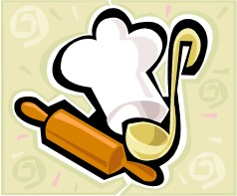

***SD CDM Skill-a-thon* Foods and Cooking ID**



## The photos shown here are only one option

## of what an item may look like.

## Updated February 2020

**APPLIANCES**

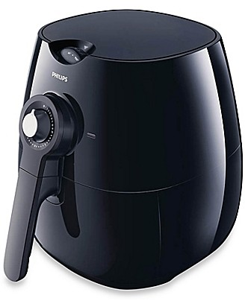



**Air Fryer –** An air fryer is a kitchen appliance that uses superheated air to cook foods, giving results very similar to deep-frying or high-temperature roasting. Air fryers use the same technology as convection ovens, but instead of blowing the air around a large rectangular box, it is blown around in a compact cylinder and the food sits in a perforated basket. This is much more efficient and creates an intense environment of heat from which the food cannot escape. The goal is to have food with a crispy brown exterior and moist tender interior; results similar to deep-frying but without all the oil and fat needed to deep-fry.



**Blender –** An electrical kitchen appliance used for mixing foods or batter.

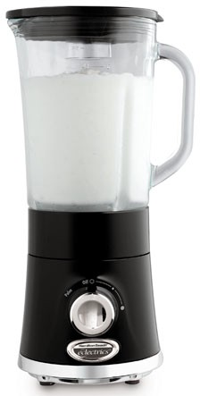



1

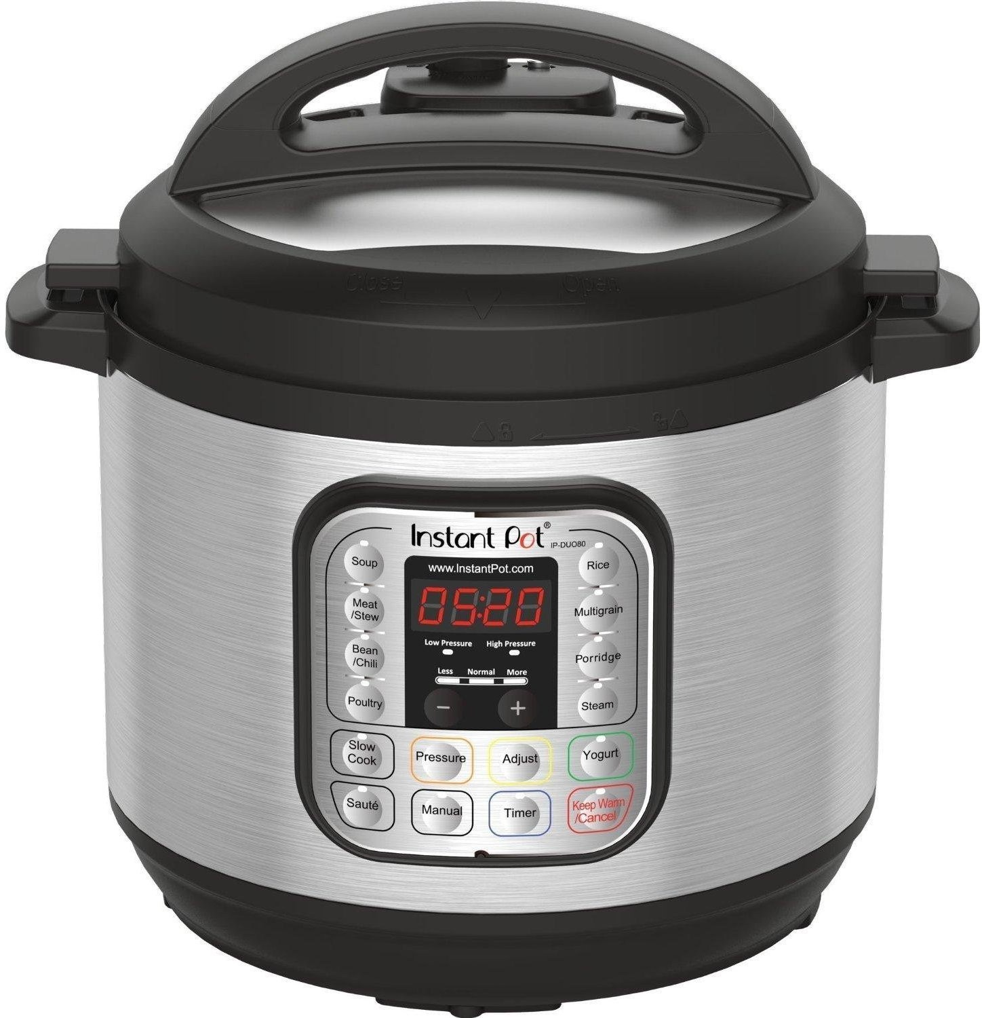



**Electric Pressure Cooker –** An electric pressure cooker consists of a pressure-cooking container (inner pot or cooking pot), the electric heating element, and temperature/pressure sensors. The heating process is controlled by the built-in micro- processor and is based on the reading of the pressure and temperature sensors. This whole process forms what is called a “closed loop control system” in control engineering terms.

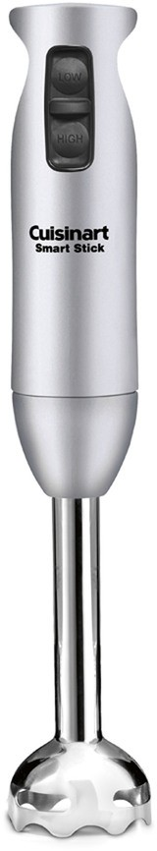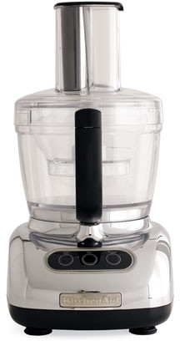



**Ice Cream Maker –** An appliance used to make ice cream which may involve a paddle used to mix ingredients while melting ice provides a low temperature.

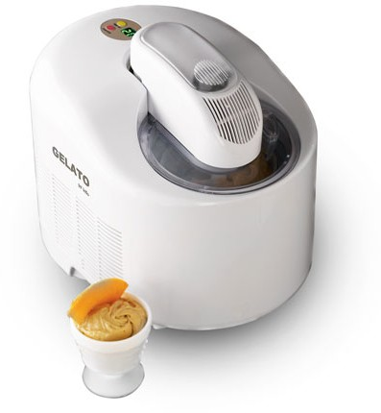



**Food Processor –** An appliance consisting of a container in which food is cut, sliced, shredded, grated, blended, beaten or liquidized using a variety of blades.



I**mmersion blender** – A kitchen blade grinder used to blend ingredients or purée food in the container in which they are being prepared. Uses include puréeing soups and smoothies; and emulsifying sauces.



2

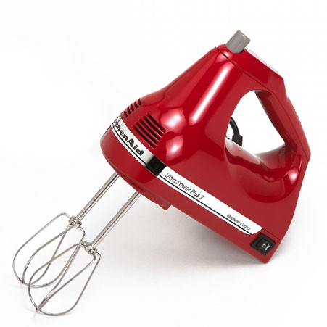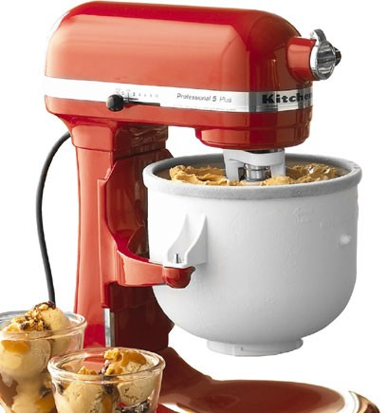



**Mixer, Hand –** A hand-held device that blends or mixes substance or ingredients by mechanical agitation using a variety of blades or beaters. Less powerful than countertop version.



**Mixer, Countertop –** An electrical device that blends or mixes substances or ingredients by mechanical agitation of a variety of blades or beaters.

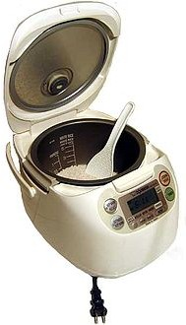



**Rice Cooker –** An automated kitchen appliance designed to boil or steam rice. It consists of a heat source, a cooking bowl, and a thermostat. The thermostat measures the temperature of the cooking bowl and controls the heat. Complex rice cookers may have many more sensors and other components and may be multipurpose.



3

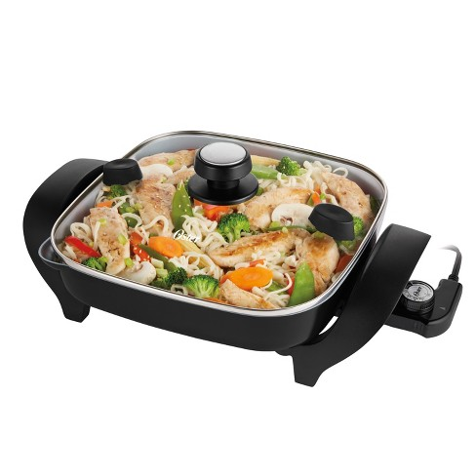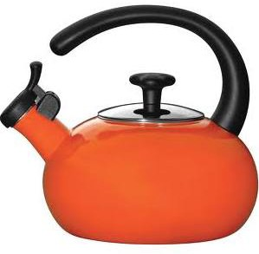



**Tea Kettle –** A metal or plastic vessel with a lid, spout, and handle used for boiling water.



**Skillet, Electric –** A skillet or frying pan that instead of being placed on the stove is heated by plugging it into an outlet. The best skillets provide an even heating surface, not always case with stovetop cooking.

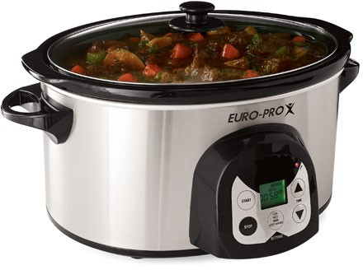



**Slow Cooker –** An electrical cooker that maintains a relatively low temperature, used to cook foods over a long period of time.

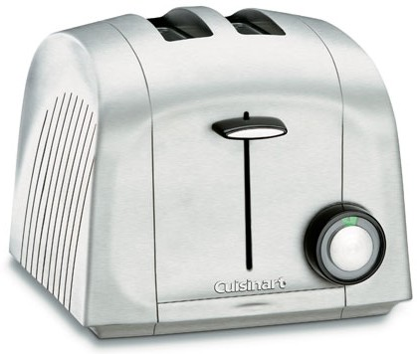



**Toaster –** A electric appliance designed to brown multiple types of sliced bread by exposing it to radiant heat, thus converting it into toast.



4

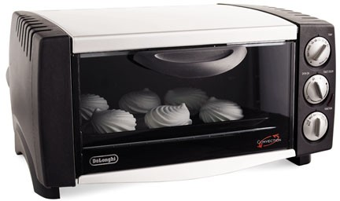



**Toaster Oven –** An electrical appliance with a hinged door in the front that opens to allow food items to be placed on a rack, which has heat elements above and below the grilling are. Toaster ovens function the same as a small-scale conventional oven.

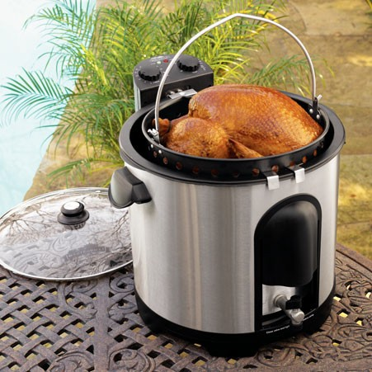



**Turkey Fryer –** An appliance used to deep fry turkeys or other large birds. This appliance uses less oil than traditional fryers and can be used to steam other foods.



**Waffle Iron –** An appliance having hinged indented planes that impress a grid pattern into waffle batter as it bakes.

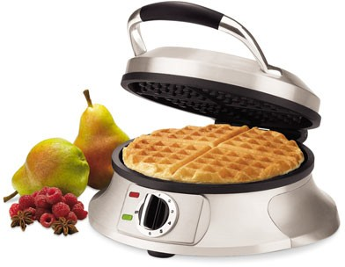



5

# COOKWARE

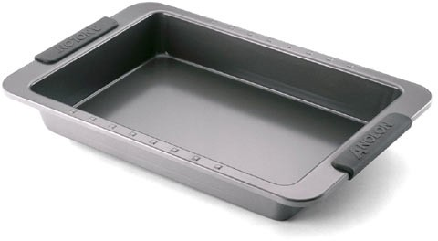



**Baking Pan –** A pan with sides that vary in deepness and are used to bake such things as cakes



**Baking Sheet –** A flat, shiny metal tray used for cooking such things as biscuits and cookies.

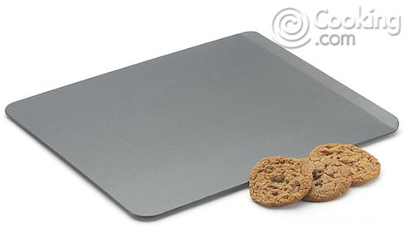

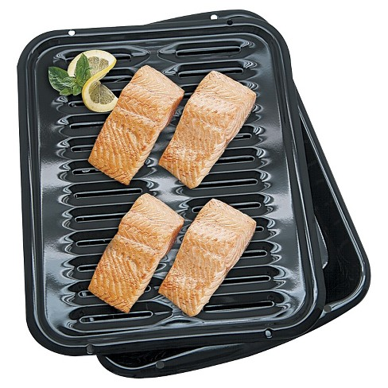



**Broiler Pan –** A two-piece pan used to grill foods in the oven. The top part is a slatted grill that lets grease, fat, and oils drip into the deeper base section. The bottom pan is often used on its own for baking or roasting.

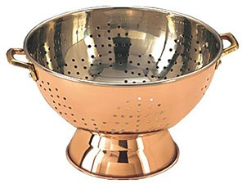



**Colander –** A perforated bowl for draining off liquids and rinsing food.



6

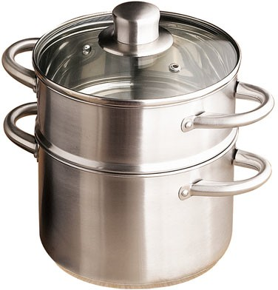



**Double Boiler –** A pair of cooking pots, one fitting on top of and partly inside the other. Food cooks gently in the upper pot while water simmers in the lower pot.

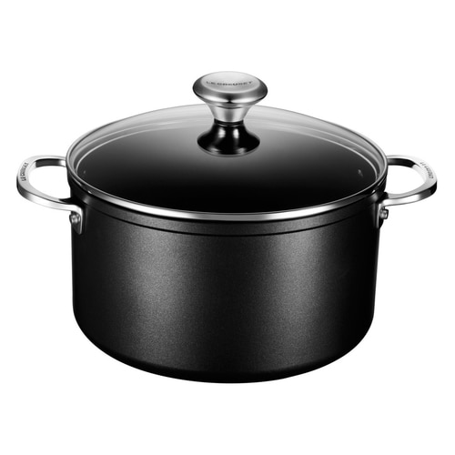



**Dutch Oven –** A heavy cooking pot with a tightly fitting lid that is good for braising. Dutch ovens are also used for making soups and stews. Often made of cast iron that can be used in the oven as well as on the stovetop.

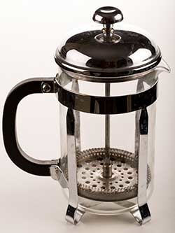



**French Press –** Also known as, press plunger pot, press coffee, coffee pusher, is a glass container for making coffee. Hot water is poured onto the coffee grounds. A punch having a sieve is pushed down, keeping the solids at the bottom. It can also serve as a serving pot when finished. The coffee is consumed quickly as there is no heating element.

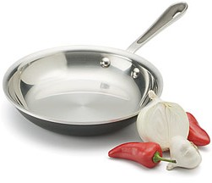



**Frying Pan –** A pan used for frying foods with a single long side handle, measured in inches and may have either straight or sloped sides.



7

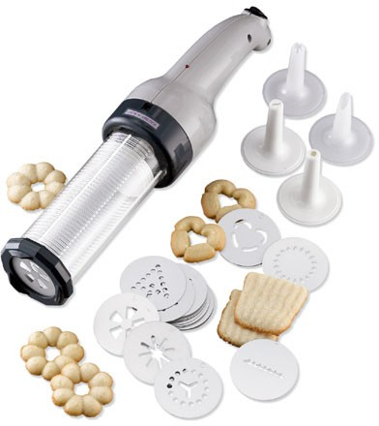



**Pastry Press –** A kitchen tool that is used to hold specific amounts of pastry dough so that it can be manually or electrically extruded from this tool onto a baking sheet or pan to create a desired shape. The press typically has a variety of different tips that create many styles and shapes of cookies or other pastry.

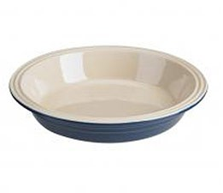



**Pie Plate –** can be made of a variety of materials, this cooking utensil has a flat bottom and slanted sides with a fluted or flat flange. Usually 1 ½ - 2 inches deep and 8-11 inches in diameter.

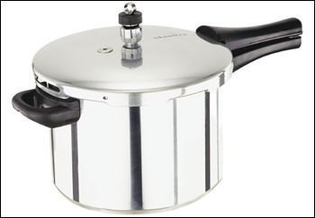

**Pressure Cooker – Conventional or Stovetop –** A cooking vessel with a lid that locks on and prevents steam from escaping. As a result, the steam builds up pressure in the pressure cooker (about 12 to 15 pounds per square inch of pressure-psi) and the temperature inside the cooker increases. That means we can cook foods inside a pressure cooker at higher temperatures, and they are therefore finished sooner (in about one third of the time it would take to cook on a regular stovetop). Time and heat are regulated manually on the cooktop.

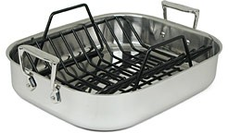



**Roaster Pan –** A pan with deep sides used to cook large pieces of meat and poultry.

May come with a rack to keep food out of juices.



8

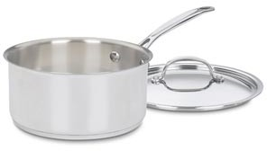



**Sauce Pan –** A pan used to cook sauces on the stovetop. It has a long side handle and straight sides measured in quarts

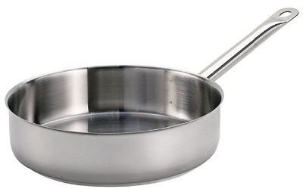



**Sauté Pan –** A sauté pan has a wide, flat bottom and vertical sides that generally go up much higher than a skillet’s flared sides do. This makes it easier to cook sauces and sear and braise meat than in a skillet.

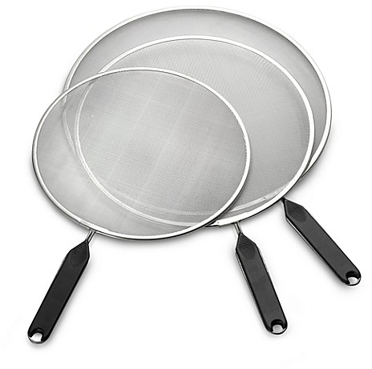



**Splatter Screen –** A kitchen tool, which helps to prevent hot grease and other hot materials from being splattered out of the pan as food is being cooked. The screen is a very fine-meshed wire utensil that is used as a cover over the open pan to keep particles of hot grease from escaping out of the pan.

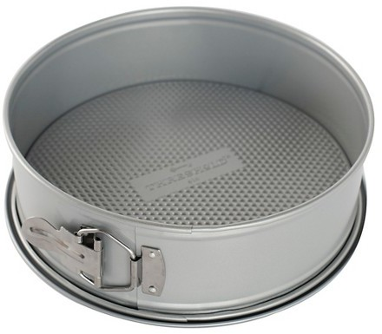



**Springform Pan –** A type of bake ware that features sides that can be removed from the base. Springform refers to the construction style of this pan. The base and the sides are separate pieces that are held together when the base is aligned with a groove that rings the bottom of the walls. The pan is then secured by a latch on the exterior wall. This tightens the 'belt' that becomes the walls of the pan and secures the base into the groove at the base of the walls.



9

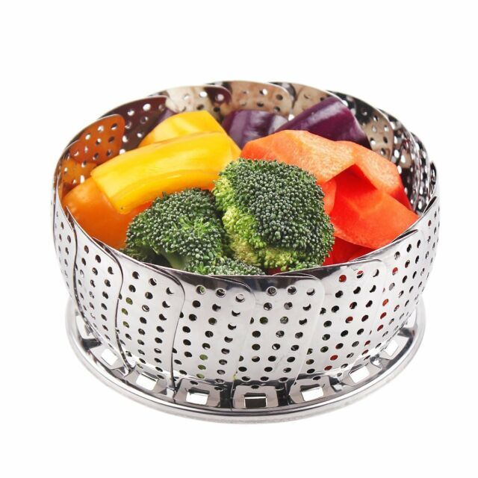



**Steamer Basket –** Metal, silicone or bamboo basket that sits inside a pan above the water level. Used for steaming vegetables.



**Stock Pot –** A tall, narrow pot with two handles and a lid. Designed to hold a large quantity of soup or stock.

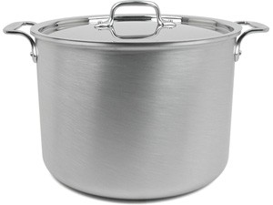



**Trivet –** An object placed between a serving dish, bowl, or hot object and a dining table or other surface, usually to protect the surface from heat damage.

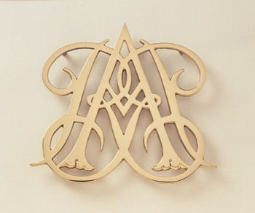



10

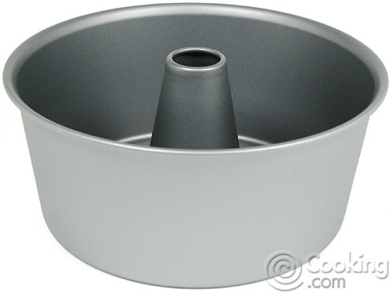



**Tube Pan –** A round pan with a hollow projection in the middle used for baking or molding foods in the shape of a ring.

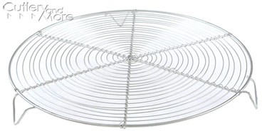



**Wire Cooling Rack –** A rack used to hold hot foods such as cakes, breads, and cookies for cooling.



11

**DISH & TABLEWARE**

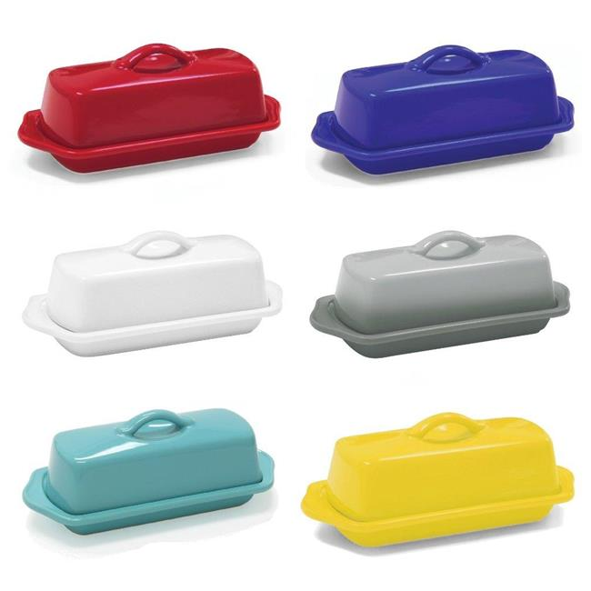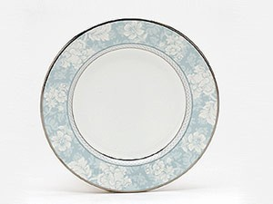



**Bread Plate –** A small plate five to six inches in diameter for

individual servings of bread and butter. Also called a butter plate.

**Butter Dish –** A small dish with a cover used to store and serve butter.



**Cake Platter –** A cake platter is a large serving plate for desserts, primarily cakes. The shape is often round, but it is characterized by having a large flat surface so that the cake sits completely flat. It may have a raised flange area or edge outside the flat space. It may be flat or raised on a pedestal.

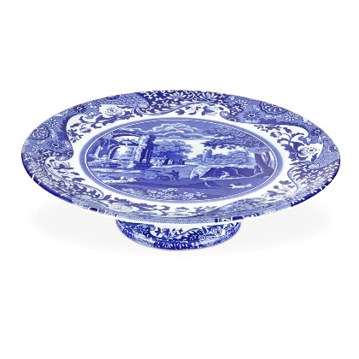



**Carafe –** A glass or metal bottle, often with a flared lip, used for serving water or wine A glass or metal pot with a handle and pouring spout used in making coffee.

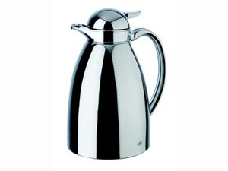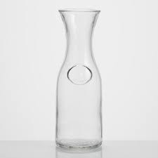

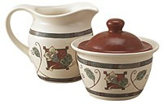



**Creamer and Sugar Set –** A matching pair of dishes; one with a spout used to hold and serve liquid cream, and the second with a cover which is used to hold and serve granulated sugar.



12

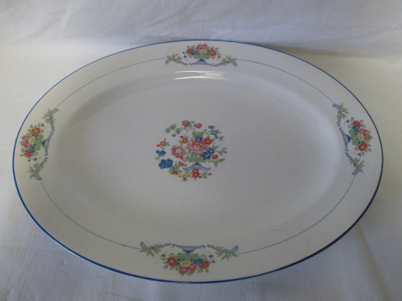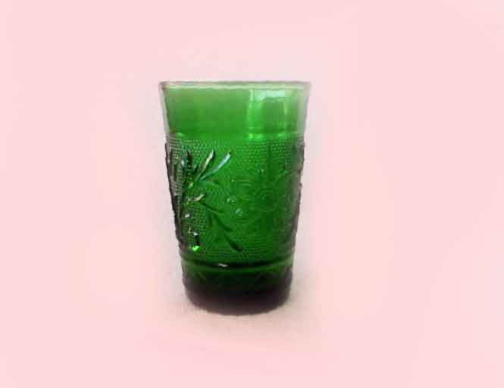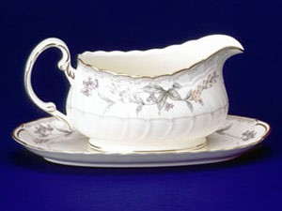



**Juice Glass –** A small glass used to serve juices.



**Gravy Boat –** Used for serving gravies and sauces. Gravy boats can have attached or detached underplates.

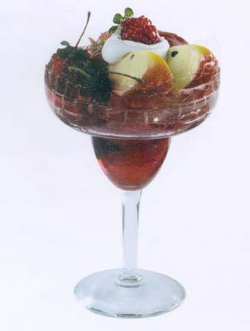



**Parfait Cup –** Designed for serving layered desserts, including ice cream sundaes, parfait and mousse.



13

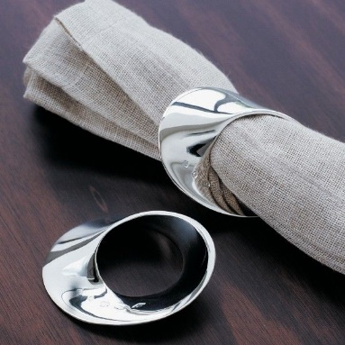

**Napkin Ring –** A circular band used

to hold an individual’s napkin.



**Meat Platter –** A large oval or oblong serving plate in a variety of sizes ranging from 12” – 20” long.



**Pepper Mill –** A utensil used for

grinding whole peppercorns.



**Punch Bowl –** A large bowl for serving a beverage, such as punch

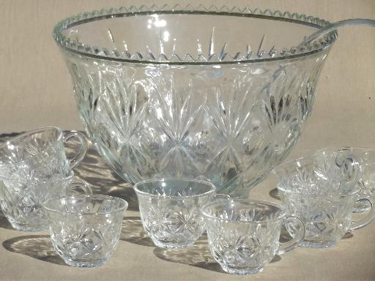

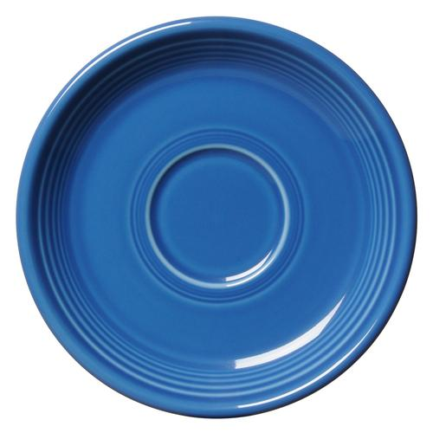



**Saucer –** A small shallow dish having a slight circular depression in the center for holding a cup.

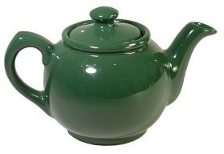



**Tea Pot –** A container with a handle and spout for serving tea.



14

**HERBS & SPICES**

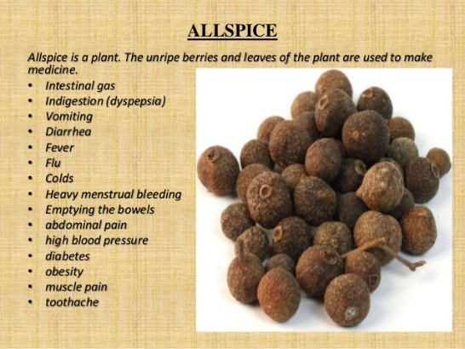

**Allspice –** A spice used especially in baking made from dried, nearly ripe berries of this plant.

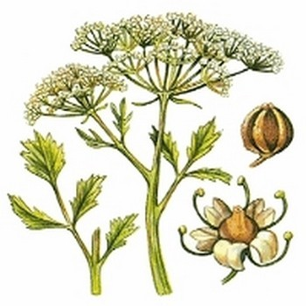

**Anise –** An annual, aromatic Mediterranean herb. (Pimpinella asisum) in the parsley family, cultivated for its seed-like fruits and the oil obtained from them is used to flavor foods, liquors, and candies.

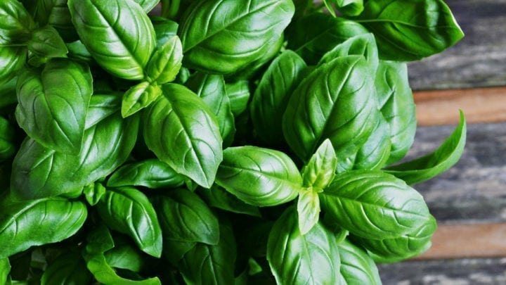

**Basil –** An Old World aromatic annual herb (Ocim basilicum) in the mint family, cultivated for its leaves. Also called sweet basil. The leaves of this plant are used as a seasoning. Any of various plants in the genus Ocimiun, native to warm regions, having aromatic foliage and terminal clusters if small, usually white flowers.

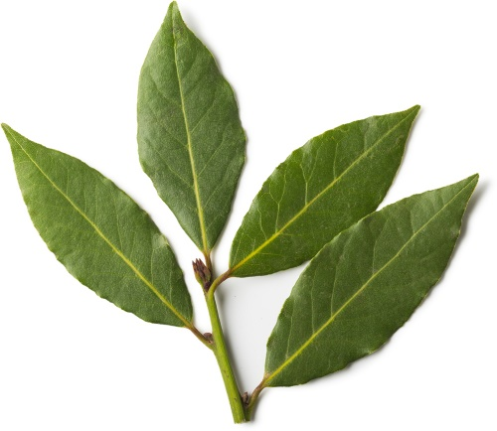

**Bay Leaves –** The leaf of the bay laurel or “true laurel.” Laurus nobilis is a culinary herb often used to flavor soups, stews, braises, and pate’ in Mediterranean Cuisine.

15

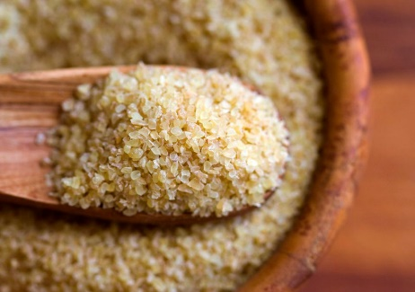



16



**Bulgur –** Bulgur wheat is a whole wheat grain that has been cracked and partially pre-cooked. There are two main kinds of bulgur

wheat: Instant bulgur wheat, also called fine-grain bulgur is usually used in tabbouleh recipes. This type of bulgur cooks in less than 5 minutes. Medium grain and coarse grain varieties of bulgur wheat are also available

### .

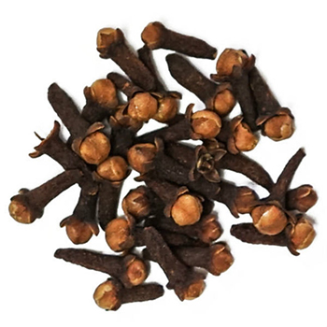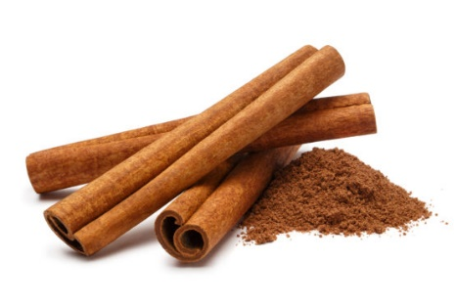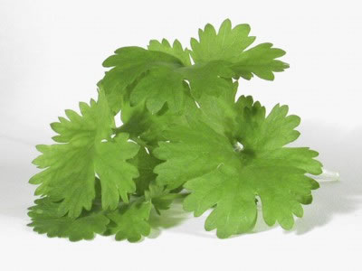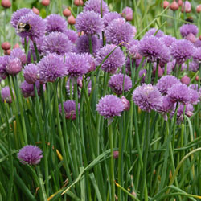



**Cloves –** The flower bud of this plant is used whole or ground as a spice. An evergreen tree (Syzygium aromaticum)native to the Moluccas and widely cultivated in warm regions for its aromatic dried flower buds.



**Cinnamon –** The dried aromatic inner bark of certain tropical Asian trees in the genus Cinnamomum, especially C. vernum and C. loureirii, often ground and used as a spice.

**Cilantro –** Parsley like herb that is used as a seasoning or garnish, usually in Mexican dishes and salsas, sometimes referred to as Mexican parsley.

**Chives –** A Eurasian bulbous herb (allium schoenoprasum) in the lily family, having clusters of usually pink to rose-violet flowers and cultivated for its long, slender, hollow leaves. Often used in the plural. The leaves of this plant are used as a seasoning.

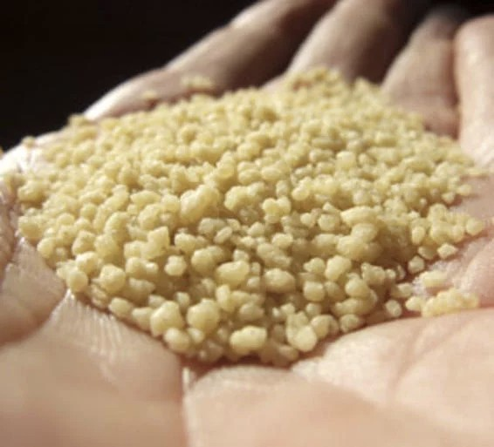



**Couscous (KOOS-koos)** – A dish made from tiny granules of durum wheat. It is prepared by steaming them until they have a light, fluffy consistency. Couscous is closely related to pasta, as durum wheat, ground into semolina flour is the same type of wheat that is most commonly used for making pasta. Couscous originated in North Africa, where it is traditionally prepared as part of a meat or vegetable stew.

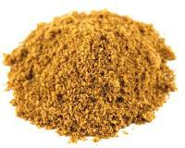



**Cumin –** An annual Mediterranean herb (Cuminum cyminum) in the parsley family, having finely divided leaves and clusters of small white or pink flowers. The seed-like fruit of this plant is used for seasoning, as in curry and chili powders.

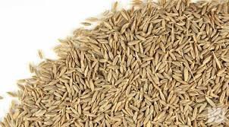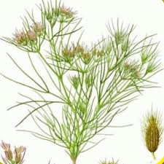

**Curry Powder -** A powdered preparation of pungent ground spices and other ingredients, usually including turmeric and coriander; often associated with East Indian Cookery to flavor

dishes of vegetables, onions, meat, or fish and often eaten with rice.

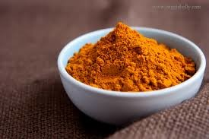

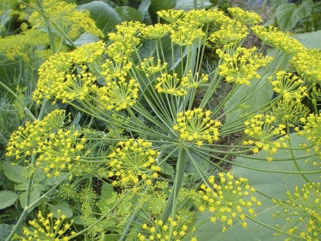



**Dill –** An aromatic herb (Anethum graveolens) native to Eurasia, having finely dissected leaves and small yellow flowers clustered in umbels. The leaves or seeds of this plant are used as a seasoning.

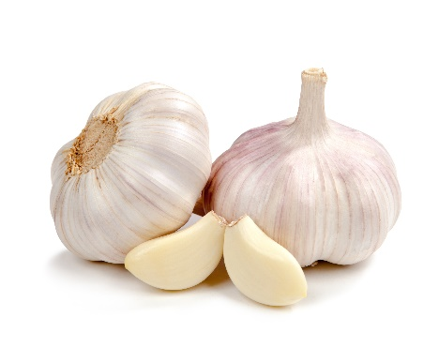



**Garlic -** A strong-smelling pungent-tasting bulb, used as a flavoring in cooking and in herbal medicine.



17

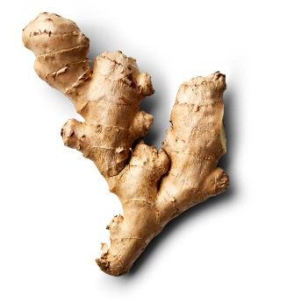

**Ginger –** A plant (Zingiber officinale) of tropical Southeast Asia having yellowish green flowers and a pungent aromatic rhizome. The rhizome of this plant is often dried and powdered and used as a spice. Also called gingerroot.

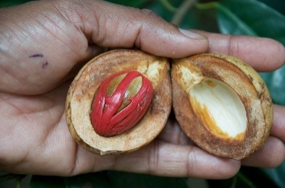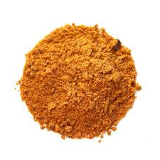

**Mace –** An aromatic spice made from the dried, waxy scarlet or yellowish covering that partly enclosed the kernel of the nutmeg.



**Mustard –** Any of various Eurasian plants of the genus Brassica, especially B. nigra and B. juncea, which are cultivated for their pungent seeds and edible leaves. A condiment made from the powdered seeds of certain varieties of these plants.

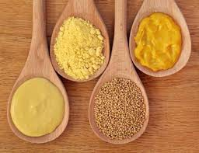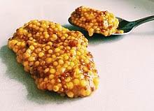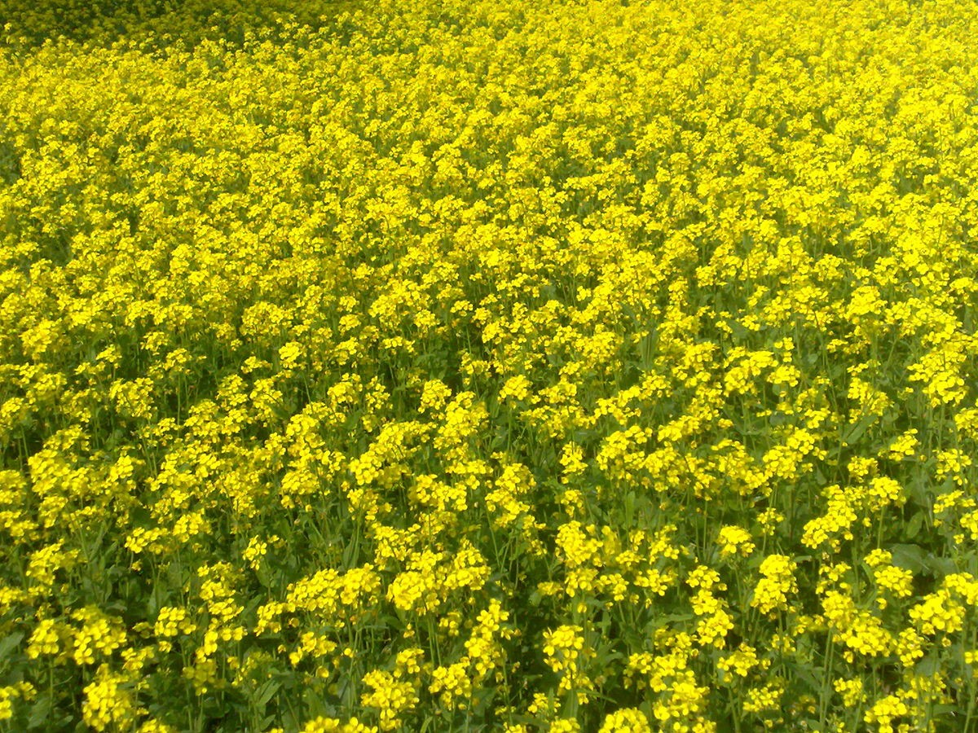

**Oregano –** A perennial Eurasian herb (Origanum vulgare) of the mint family, having aromatic leaves. The leaves of this plant are used as a seasoning.

Pungent leaves used as seasoning with meats and fowl and in stews and soups and omelets.

18

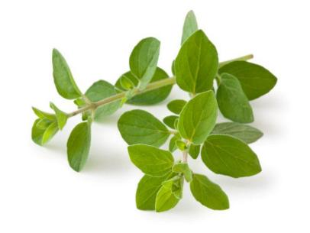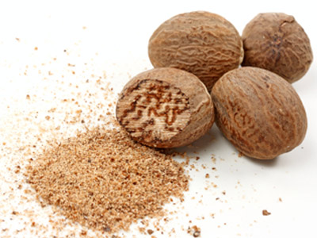



**Nutmeg –** An evergreen tree (Myristica fragrans) native to the East Indies and cultivated for its spicy seeds. The hard, aromatic seed of this tree is used as a spice when grated or ground. A grayish to moderate brown.

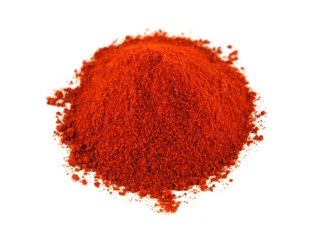



**Paprika –** A mild powdered seasoning made from sweet red peppers. It can be a dark to deep or vivid reddish orange.

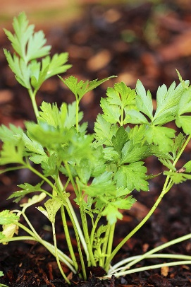



**Parsley -** A cultivated Eurasian herb (Petroselinum crispum) having flat or curled, alternately compound leaves. The leaves of this plant are used as a seasoning or garnish.

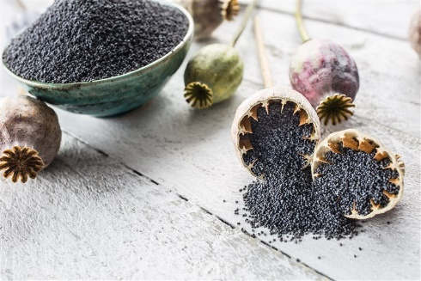



**Poppy Seed –** Any plant or species of the genus Papaver, herbs with showy polypetalous flowers and a milky juice. From one species (Papaver somniferum)opium is obtained, though all the species contain it to some extent; also, a flower of the plant.

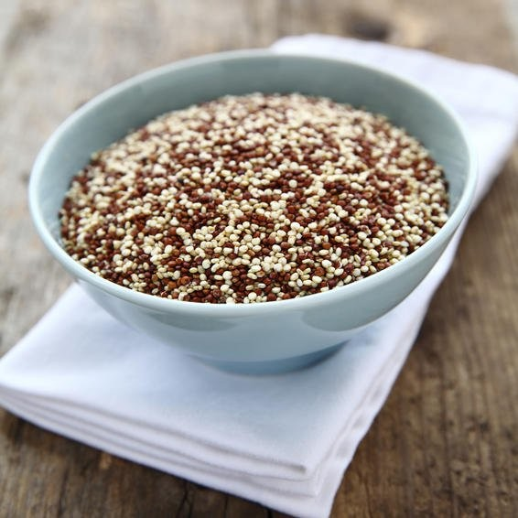



**Quinoa (kEEN-wah)** – A plant of the goosefoot family found in the Andes of South America, where it was widely cultivated for its edible starchy seeds prior to the introduction of Old World grains. Quinoa was once the staple food of the Incas and was known as “the mother grain” in ancient time, but it's a seed with a nutty flavor. It is usually found in tan or yellow form — though it comes in many colors: orange, red, pink, purple, and black.



**Rosemary –** An aromatic evergreen Mediterranean shrub (Rosmarinus officinalis) having light blue or pink flowers and grayish-green leaves that are used in cooking and perfumery. The leaves of this plant are used as a seasoning.

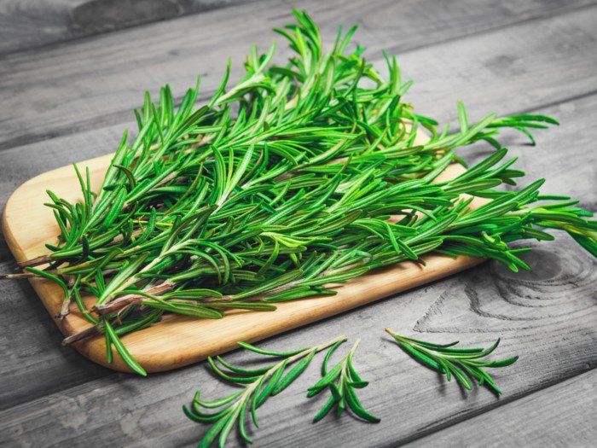



19

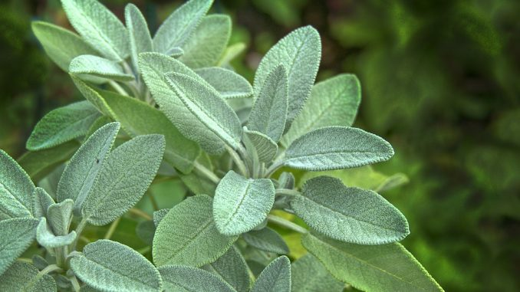

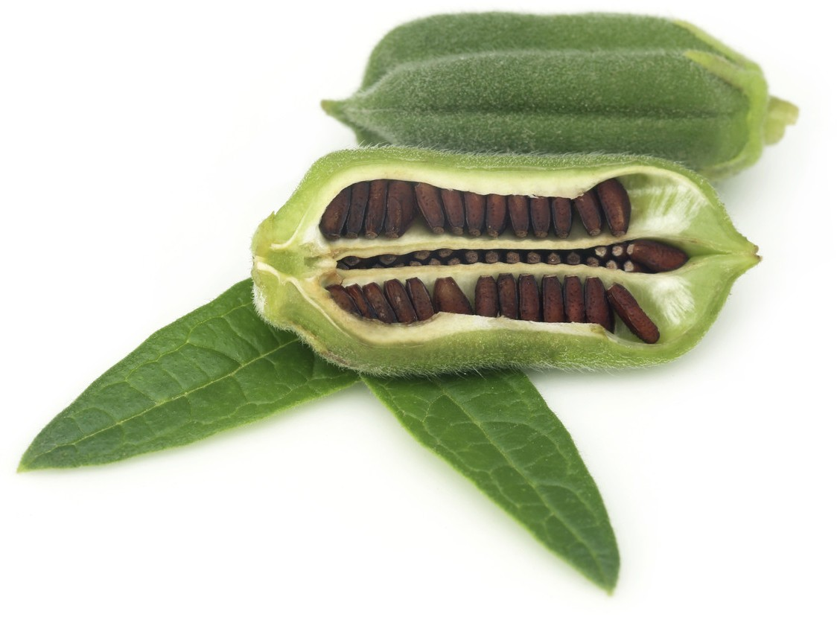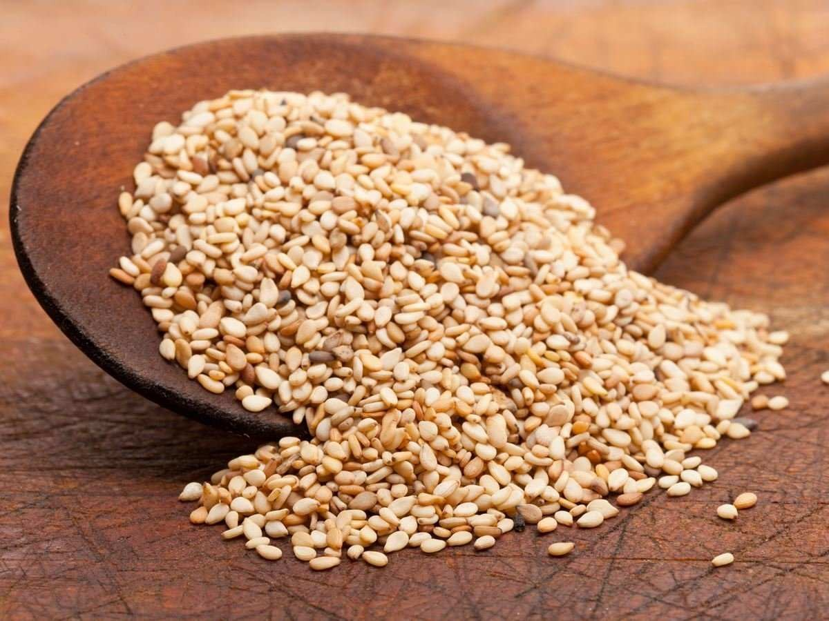

**Sage –** Any of various plants of the genus Salvia, especially

S. officinalis, having aromatic grayish-green, opposite leaves. Also called ramona. The leaves of this plant are used as a seasoning



**Sesame Seed –** Small oval seeds of the flowering plant in the genus Sesamum, also called benne It is widely naturalized in tropical regions around the world and is cultivated for its edible seeds, which grow in pods or "buns". They are the main ingredients in tahini, sesame seed paste.

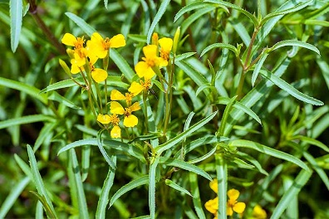



**Tarragon –** An aromatic Eurasian herb (Artemisia dracunculus) having linear to lance-shaped leaves and small, whitish-green flower heads arranged in loose, spreading panicles. The leaves of this plant are used as a seasoning.

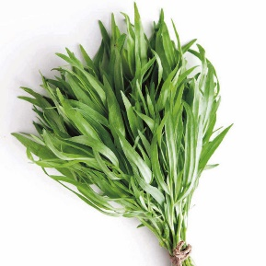

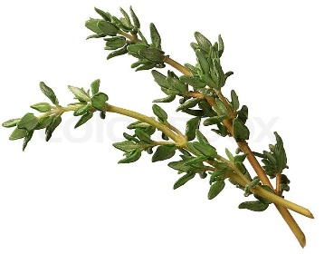

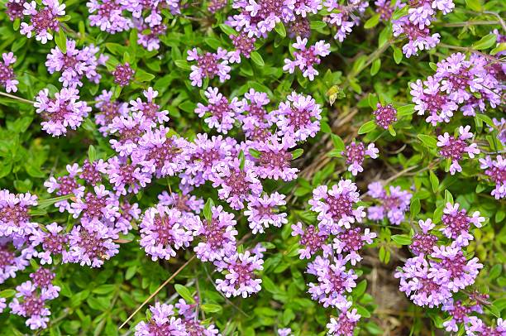

20

**Thyme –** Any of several aromatic Eurasian herbs or low shrubs of the genus Thymus, especially T. bulgaris, of southern Europe. Thyme has small, white to lilac flowers grouped in head-like clusters. The leaves of this plant are used as a seasoning.



20

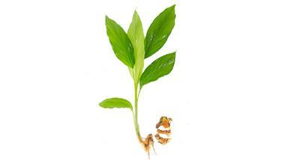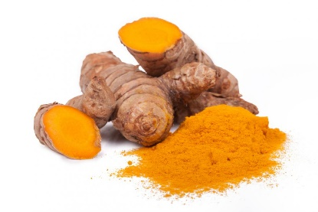

**Turmeric –** A widely cultivated tropical plant (Curcuma Domestica) if India, having yellow flowers and an aromatic, somewhat fleshy rhizome. The powdered rhizome of this plant is used as a condiment and a yellow dye.

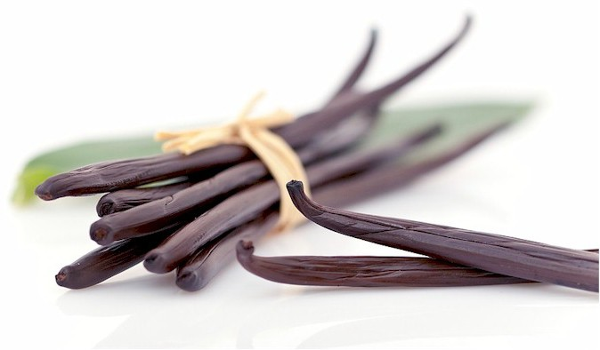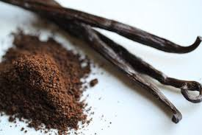



**Vanilla –** The fruit of the vanilla plant which is cured and then either used in bean form in cooking or processed to extract an essence which is used for flavor.



21

**UTENSILS**

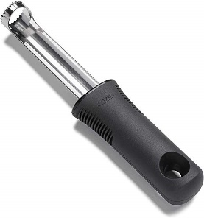

**Apple Corer –** This tool has a circular cutting edge that is forced down into the apple, allowing the apple to remain whole. This tool is used to extract the core from the apple without cutting the apple into sections and then having to individually cut out each part of the core.

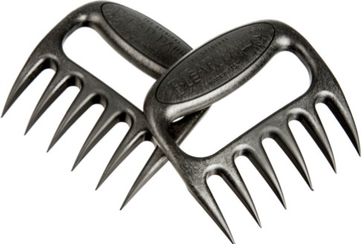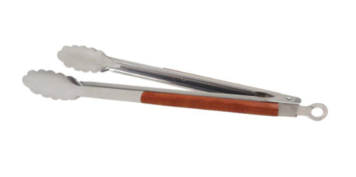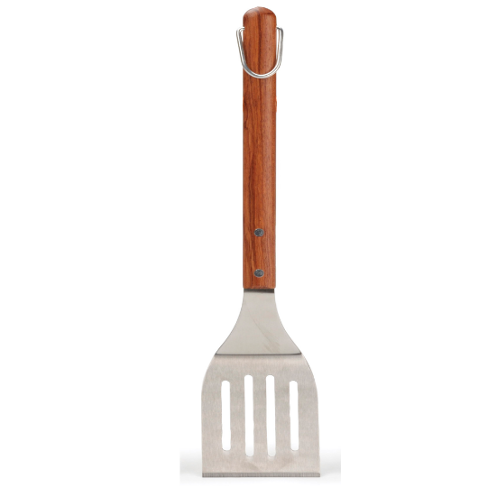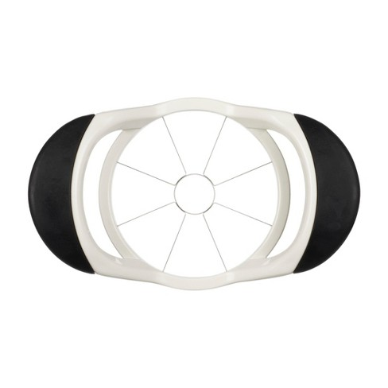

22

**Bear Claws –** A grip handled fork with sharp, claw like tines designed for pulling pork, shredding chicken, lifting turkey, tossing salads, and more. Usually made of hard plastic or stainless steel.

**BBQ Tongs –** A utensil with long handles used to grip and turn food while cooking.

**BBQ Spatula –** A utensil with a long handle and flat bottom used to turn food while cooking.

**Apple Slicer –** This professional quality tool is pressed down over the apple to make eight uniform slices and remove the core.

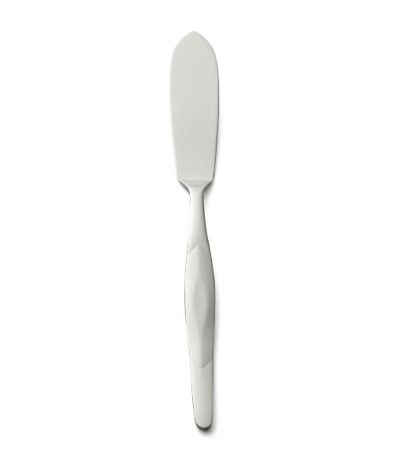

**Butter Knife –** A blunt knife used for cutting or spreading butter or other spreads.

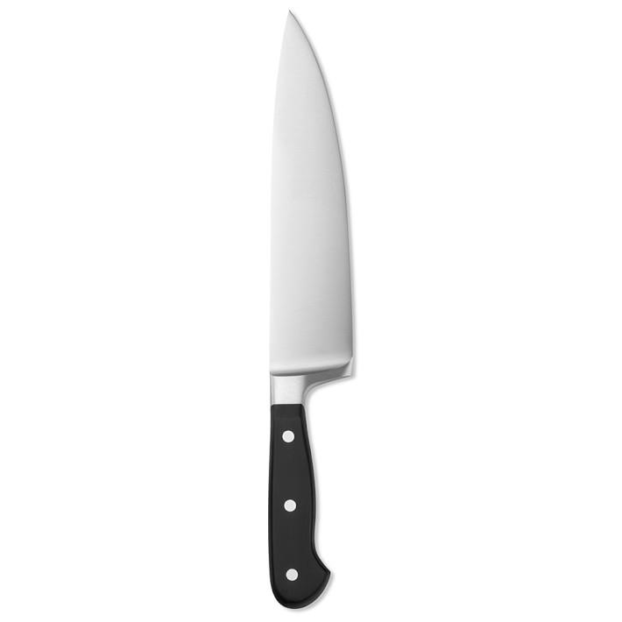

**Chopper –** A utensil used to cut food into smaller pieces.

**Chef’s Knife –** A large knife with a wide blade, generally considered all-purpose knives that are used for cutting and dicing.

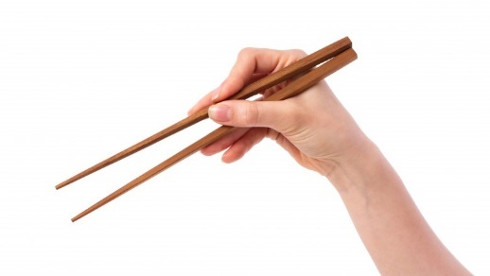

**Chopsticks –** A pair of sticks made especially of wood or ivory, held between the thumb and fingers and used as an eating utensil in Asian countries and in restaurants serving Asian food.

23

**Citrus Reamer –** A citrus reamer is a small kitchen utensil used to extract the juice from a lemon or other small citrus fruit. It consists at one end of a convexly tapered conical blade with deep straight troughs running the length of the blade. The very tip of the blade is often a smooth spike. The other end is a cylindrical handle. The blade is usually made of wood, plastic, or metal.

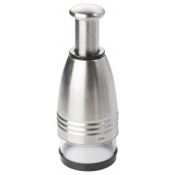

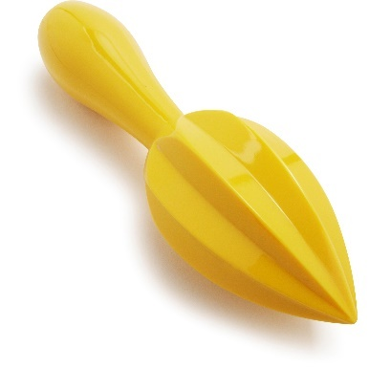

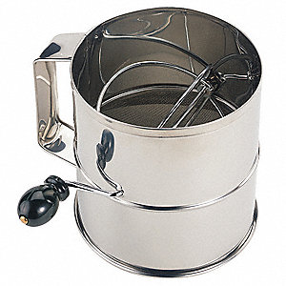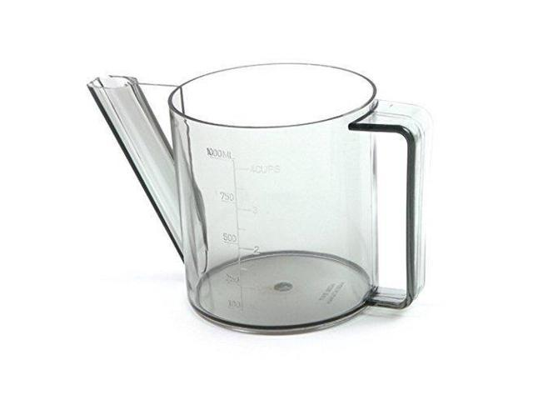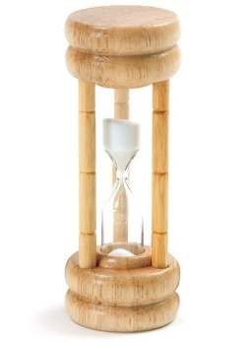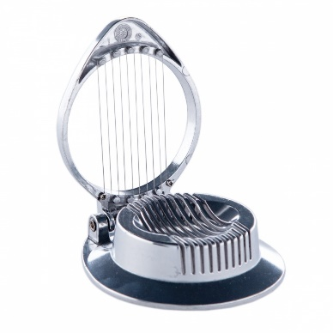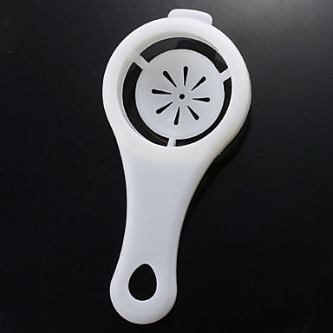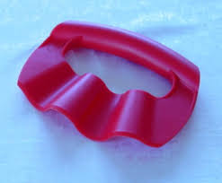

24

**Flour Sifter –** A utensil used to incorporate air into flour and other dry ingredients.

**Fat Separator –** A cooking utensil that enables liquid fat to be gathered and removed from juices that come from roasted meats, stews, soups, and stocks. When fat cannot be easily skimmed, it can be poured into a separator. This will hold the contents to allow the fat to accumulate on the surface while the juices accumulate below. The juices can then be easily poured out of a spout attached to the bottom of the container so that the fat is all that remains in the separator.

**Egg Timer –** A small hourglass or clock timing device used to time the boiling of an egg, usually capable of timing intervals of three to five minutes.

**Egg Slicer –** A kitchen tool with a slatted, egg shaped hollow on the bottom and a hinged top consisting of 10 fine steel wires. When the upper portion is brought down onto a hard-cooked egg siting in the base, it cuts the egg into even slices. May also resemble a small apple corer which slices the egg into equal wedges.

**Egg Separator –** A spoon shaped utensil, which has a hole in the bottom and is used to separate the white from the yolk of the egg.

**Decorative Slicer-Ripple –** A utensil used to cut food that leaves a rippled edge.

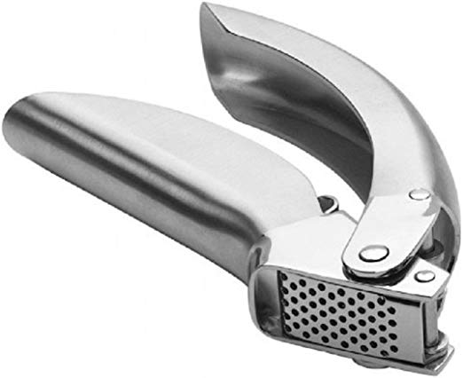

**Garlic Press –** A press used for extracting juice from garlic.

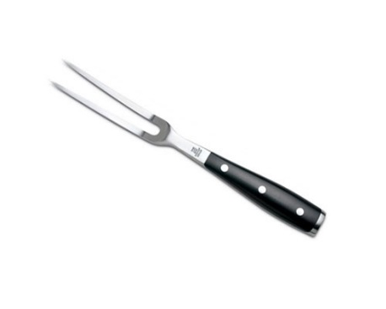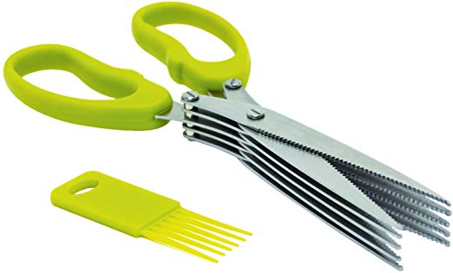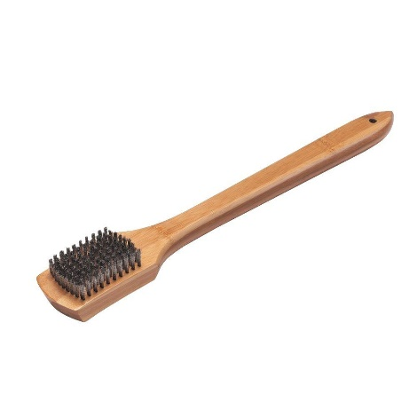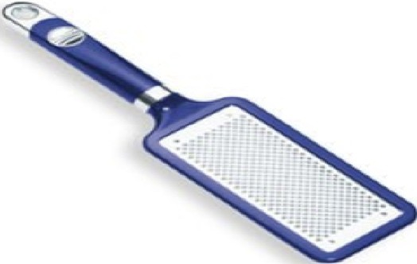

**Kitchen Fork –** A utensil used to lift or turn small food.

**Herb Scissors –** Scissors designed with five blades and used to cut herbs. These multiblade scissors quickly cut herbs into thin strips (sometimes called chiffonades). Stainless steel blades cut cleanly, without tearing or bruising delicate leaves.

**Grill Brush –** A brush with a long handle on the end that is used to clean a grill to remove food residue.

**Grater –** A device with sharp edged holes against which reduces it to shreds. Used to grade such things as cheese.

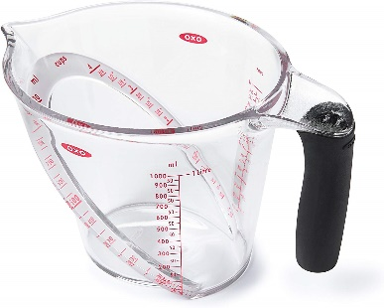

25

**Liquid Measuring Cups –** Cups that come in clear plastic or glass with a 1/4” headspace so liquid can be carried without spilling and a pouring spout.

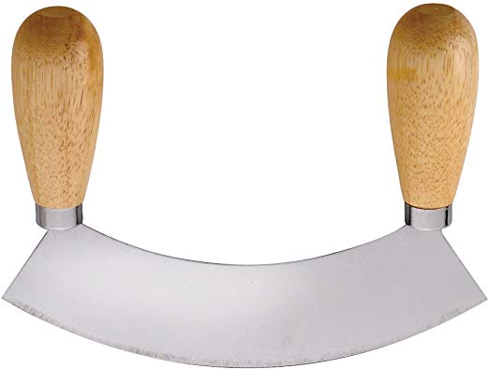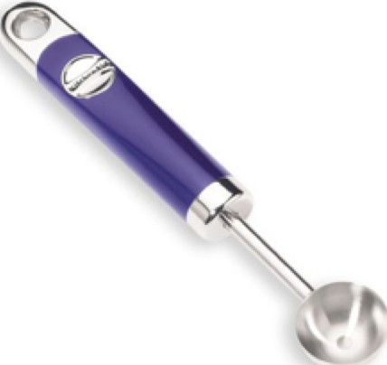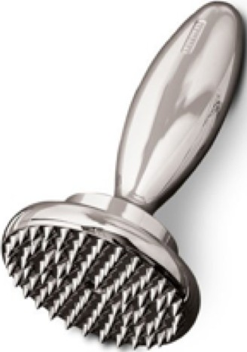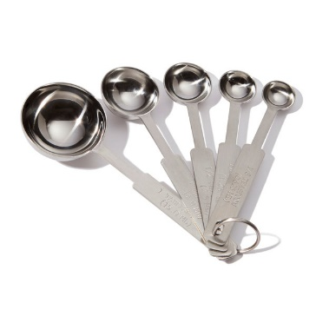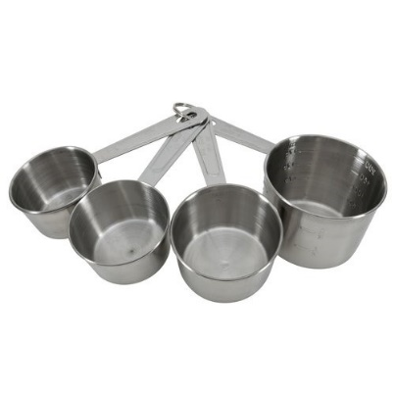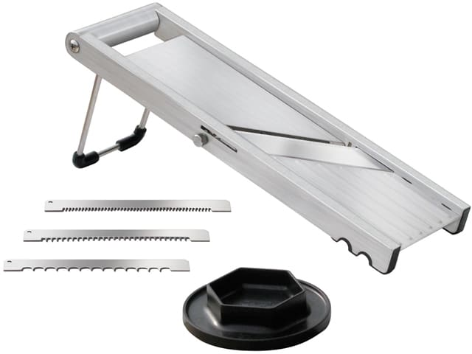

26

**Mezzaluna –** A mezzaluna is a knife consisting of a single or double curved blade with a handle on each end, which is rocked back and forth chopping the ingredients below with each movement. It is typically used for mincing herbs or garlic, but it can be used for chopping other things such as cheese or meat. Very large single blade versions are sometimes used for pizza.

**Melon Baller –** A small bowl-shaped tool used to cut round or oval shaped pieces of melon. The best melon ballers are rigidly constructed with wood or metal handles and sharp edged, stainless steel bowls, which come in several sizes, from about 1/4 inch to 1 inch.

**Meat Tenderizer –** Hammer or paddle type utensil that comes in metal or wood and in a plethora of sizes and shapes. They can be large or small, have horizontal or vertical handles and be round, square, or mallet shaped. Some have smooth surfaces with others are ridged.

**Measuring Spoons –** Spoons that are used to measure small amounts of dry or liquid ingredients.

**Measuring Cups –** Cups that are used to measure dry and solid ingredients. They usually come in a set of four nesting cups: 1/4 cup, 1/3 cup, 1/2 cup, and 1 cup. A 3/4 cup measure is sometimes included.

**Mandolin Slicer –** A hand operated appliance used for cutting and slicing fruits and vegetables. This kitchen utensil has a variety of adjustable blades that enable the mandolin to make precise cuts in firm fruits and vegetables, such as apples, melons, carrots, cucumbers, eggplants, onions, potatoes, sweet peppers, zucchini, and other foods.

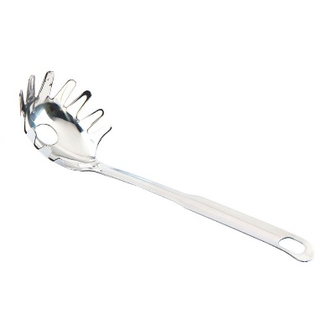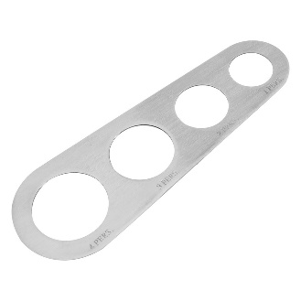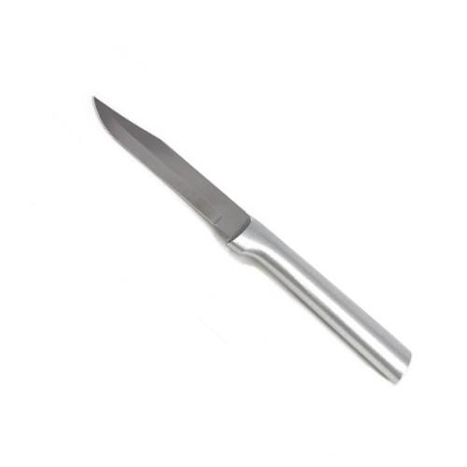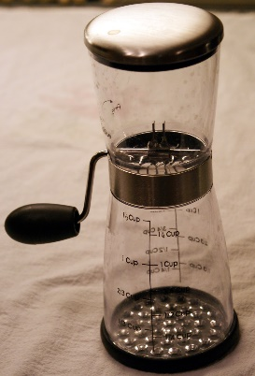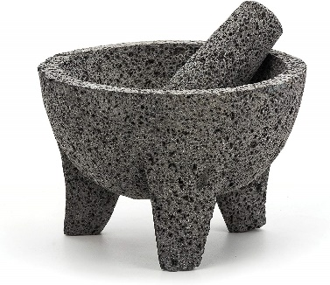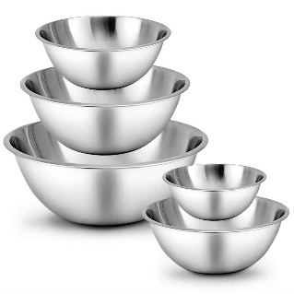

27

**Pasta Server –** A type of serving utensil which is used to hold the long pasta noodles enabling them to be easily removed from a pot of boiling water. The spoon shaped tool has protruding wood or metal prongs that allow the noodles to be grasped, separated, and placed on a plater after they are removed from the water. Most have a hole in the center to drain the water as the noodles are lifted out.

**Pasta Measurer –** A kitchen tool designed to accurately gauge the amount of uncooked pasta that will be needed for serving from 1 to 4 portions of pasta. Typically, it a flat with 4 round openings spaced evenly over the surface.

**Paring Knife –** A thin bladed knife intended for coring and paring (peeling) fruit such as apples as well as slicing small ingredients. It is majorly used for detailed and controlled cutting. The typical paring knife has a short, sturdy blade, from 2-4 inches in length with a straight or curved cutting edge.

**Nut Chopper –** A device with blades that chops nuts into small pieces which fall into the bottom portion of the chopper.

**Molcajete –** A molcajete is a stone tool, the traditional Mexican version of the mortar and pestle, like the South American batan, used for grinding various food products. Molcajetes are used to crush and grind spices and to prepare salsas and guacamole. Traditionally carved out of a single block of vesicular basalt.

**Mixing Bowl –** A large bowl made of pottery, glass, metal, or plastic used to mix ingredients and comes in a variety of sizes.

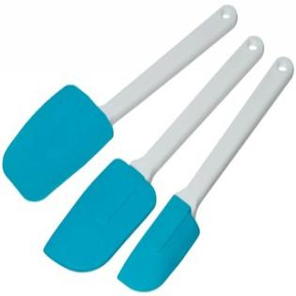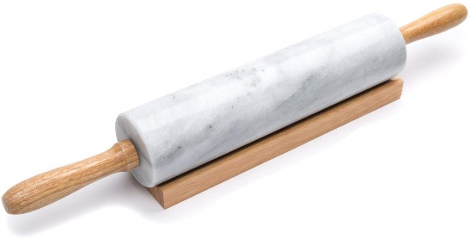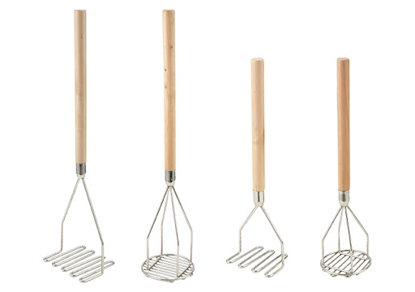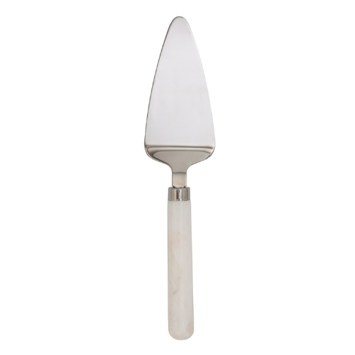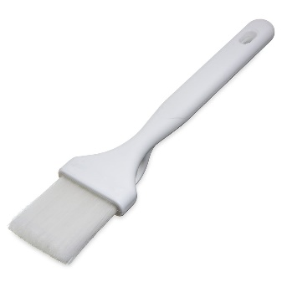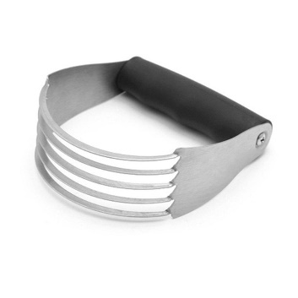

28

**Rubber Spatula –** A flexible utensil used to remove food from spoons, sides of bowls, and pans.

**Rolling Pin –** A cylinder that may or may not have small handles at either end used to roll dough for pie crusts, biscuits, or cookies.

**Potato Masher –** A tool used to crush food, usually after cooking it, so that it forms a soft mass.

**Pie/Cake Server –** A utensil which has a triangular, shaped bottom with handle and is used to serve cake or pie.

**Pastry Brush –** A small type brush used to spread butter or spices over pastry and other foods.

**Pastry Blender –** A kitchen tool used to mix a hard (solid) fat into flour in order to make pastries. The tool is usually made of narrow metal strips or wires attached to a handle and is used by pressing down on the items to be mixed (known as “cutting in”).

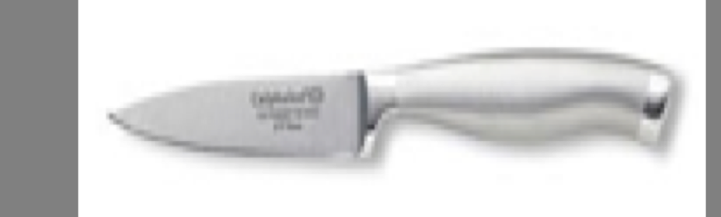

A thin-bladed knife intended for coring and paring (peeling) fruit such

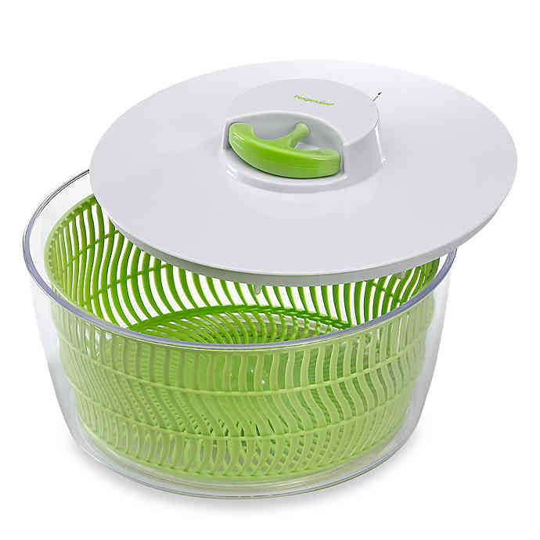

**Salad Spinner –** Also known as a salad tosser, is a kitchen tool used to wash and remove excess water from salad greens. It uses centrifugal force to separate the water from the leaves. This is necessary in order to keep the greens from going limp and enable salad dressing and oil to stick to the leaves.

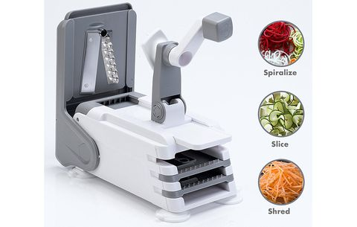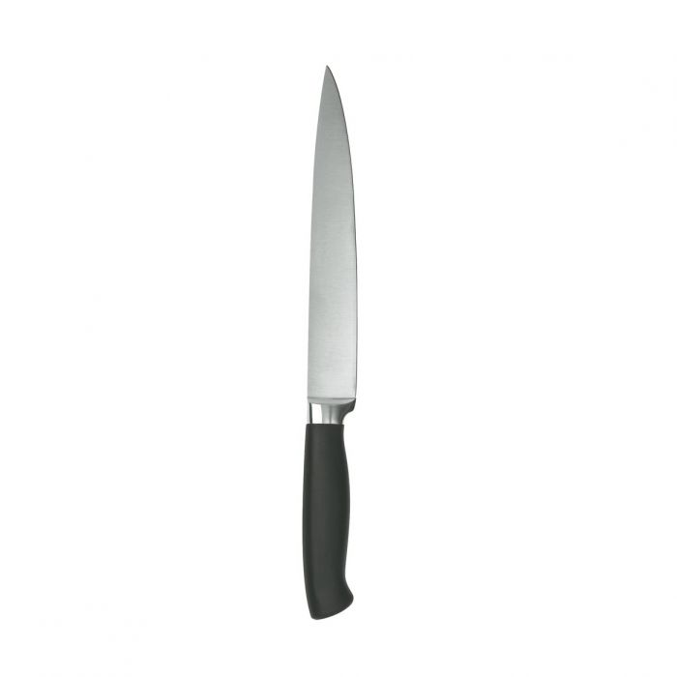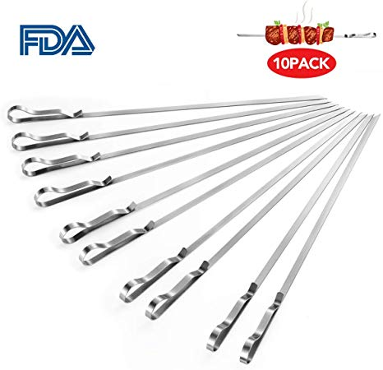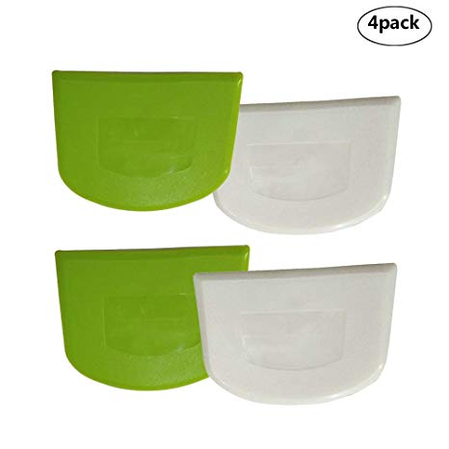

29

**Spiralizer –** A kitchen device used to cut vegetables into long ribbons or strips resembling noodles or spaghetti. It may be a handheld or counter top model.

**Slicing Knife –** A knife with long, narrow flexible blades that may or may not be serrated.

**Skewer –** A long, thin, straight shaft typically made of metal, wood, or natural materials. Used to support and hold small chunks of meat and vegetables as they are grilled or roasted. Commonly known as shish kabobs or kebabs, the food items are pierced by the skewer so they can be held firmly and roasted over the cooking heat.

**Scraper –** A stiff plastic utensil used to scrape food from bowls and other surfaces.

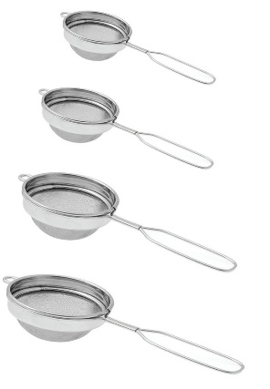

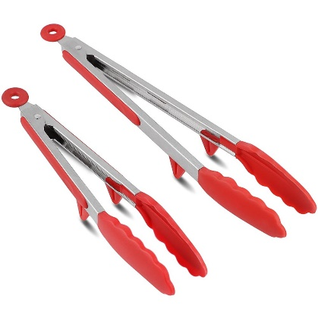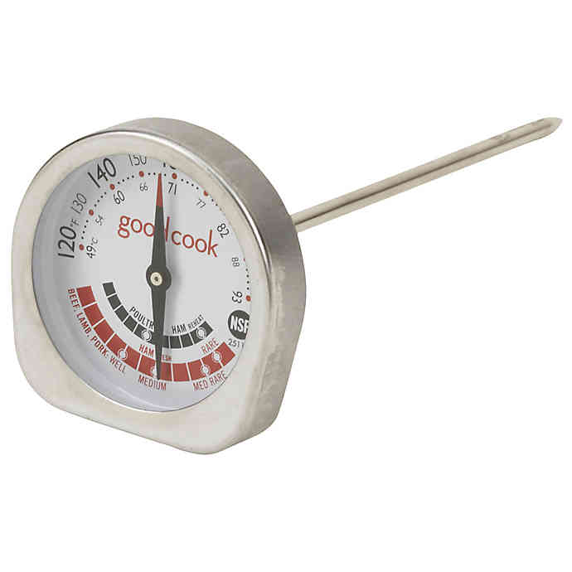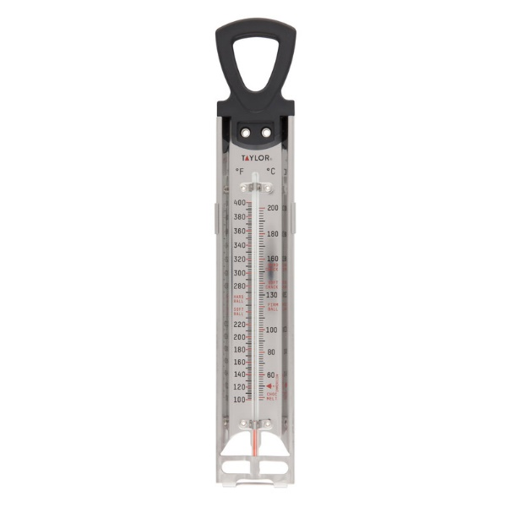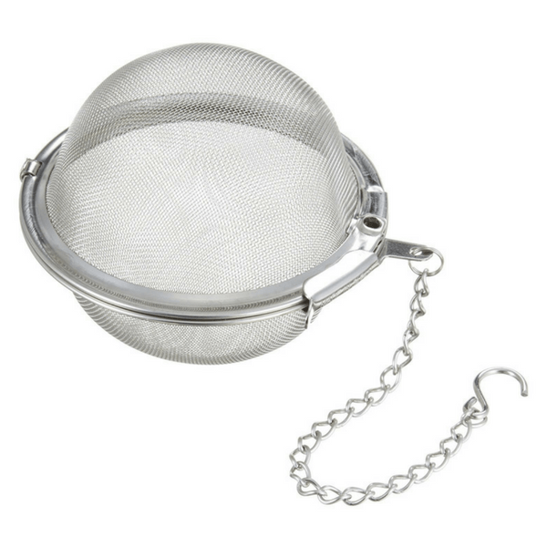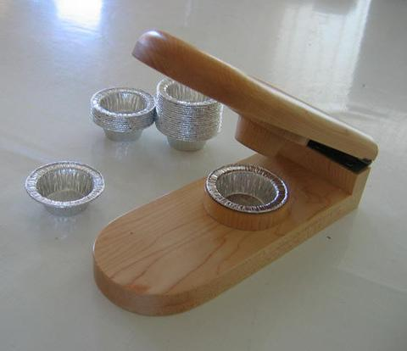

30

**Tongs –** An instrument with two movable arms that are joined at one end, used for pickup up and holding things.

**Thermometer, Meat –** A thermometer used to measure the internal temperature of meat and other cooked foods. The degree of “doneness” of meat correlates closely with the internal temperature, so that a thermometer reading indicates when it is cooked as desired.

**Thermometer, Candy –** A candy thermometer, also known as a sugar thermometer, is a thermometer used to measure the temperature and therefore the stage of a cooking sugar solution.

**Tea Infuser –** A device in which loose, dried tea leaves are placed for steeping or brewing, in a mug or a teapot full of hot water. It is often called a tea ball or tea maker, and sometimes a tea egg.

**Tart Press –** Any type of press used to shape or mold pastry.

**Strainer –** A bowl type item with holes in it that is used to separate liquids from solid food.

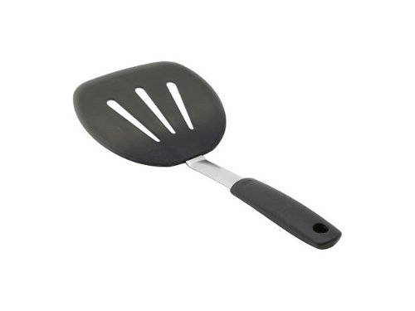

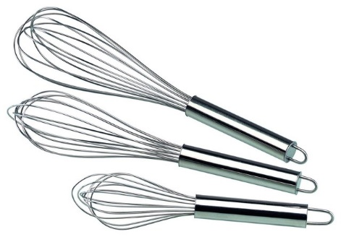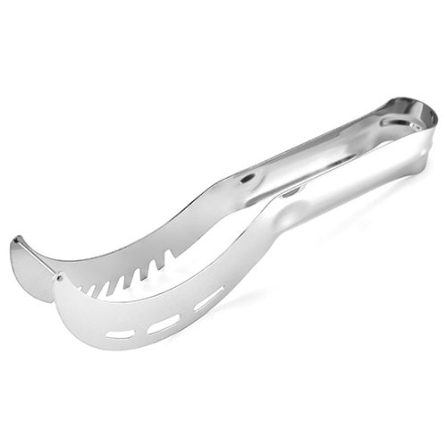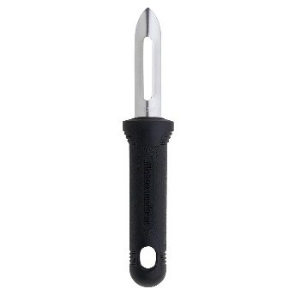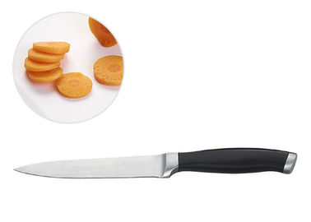

31

**Whisk –** A utensil used to beat and blend ingredients or food, especially eggs and egg mixtures. The mixing portion may be looped or another configuration and be made of stainless steel or wire coated with silicone or rubber.

**Watermelon Slicer –** A device for slicing and removing the fleshy part of a watermelon surrounded by a rind. This design allows sections to be cut and the wire slices the fleshy part of the watermelon from the rind.

**Vegetable Peeler –** A kitchen tool used to remove the layers of flesh from vegetables and firm fruits, such as apples, by peeling off thin narrow shavings.

**Utility Knife –** A small lightweight knife, which usually has a blade that is 4 to 7 inches long and is used for miscellaneous light cutting. Slightly larger than a paring knife, this utensil can cut food items that are too large for a paring knife but too small for a chef’s knife, such as cucumbers, larger apples, smaller squash, and other mid-sized items.

**Turner –** A kitchen utensil with a long handle and a broad flat edge, used for lifting and turning fried foods, biscuits, or cookies.