Fruit and Nut Production
Bill Phillips, Bob Renner and Jeff Williamson
University of Florida
Fruits and nuts comprise a wide variety of plants from small strawberry plants to various bushes, shrubs and vines to very large trees like the pecan. Some have a relatively short life span of only a few years while others may survive and produce for over a century. Most are edible right off the plant though some require some kind of processing or treatment. Avocado and pear, for example, mature on the tree but ripen after harvest, whereas the cashew nut requires a heat treatment to make it edible.

Climate
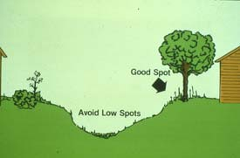
Climate is the major factor that determines the geographic areas in which certain fruits and nuts can be grown. Deciduous fruits are mainly limited to the temperate zone. They shed their leaves each fall and enter a winter dormancy that allows them to survive extended periods of sub-freezing temperatures. Many fruits such as grapes and blueberries can be grown throughout the United States. Deciduous fruits and nuts have a very difficult time producing fruit in locations with tropical climates such as that of extreme southern Florida where there are too few chilling hours during winter (see below for discussion of chilling requirements).
Tropical and subtropical fruits are mostly evergreen and can be severely damaged or killed outright by freezing temperatures. Consequently, fruits such as pineapple and papayas are limited to Hawaii, south Florida, extreme south Texas, and parts of southern California.
Climate will also influence the choice of fruit varieties for your area. Peaches, for example, can be grown in many parts of the country. Although the peach variety 'Alberta' are recommended for the northeastern US, this variety will not grow well in the southeastern US. Varieties such as ‘Flordacrest’ and ‘Flordaking’ are better suited for the milder winters in northern Florida and the southern Gulf Coast regions. Different varieties of deciduous fruits have different chilling requirements to break winter dormancy. A southern variety that is taken north will leaf out well before the last freeze. A northern variety planted in the deep south may never receive enough hours of cold temperature during the winter to resume normal growth in the spring.
Chilling requirements are commonly expressed as the number of hours below 42°F needed to break the dormancy requirements on buds. Only plants from the temperate zone have chilling requirements. Plants from the tropics do not have this characteristic. Many plants from near the Arctic Circle have not developed chilling requirements. When it finally does warm up in these frigid regions, these plants have to flower, ripen their seed, and go dormant as rapidly as possible.
Climate is more than temperature. Some fruits require a very dry or very moist climate to produce well. The climatic effect on insects and diseases is also significant. For example, a fungus called pecan scab grows well in humid weather. Since the southeastern part of this country is usually very humid, pecan growers use varieties resistant to this disease.

Soils
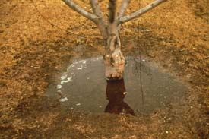
Fruits and nuts are grown on a wide variety of soil types. They generally prefer deep soils with good drainage and permeability to enable these plants to develop an extensive root system necessary for optimum growth. A poorly drained soil restricts growth by limiting oxygen to the roots. Since oxygen is necessary for the uptake of water and nutrients, soils low in oxygen will produce plants that have unthrifty growth, more disease and insect problems and fewer and smaller fruit. Even small fruits like strawberry and blueberry require deep, moist, fertile soils. Soils do not have to be as deep for these plants as for a large tree like a pecan however.
Soil pH is also very important to many fruits and nuts. While some will grow on either acid (pH<7.0) or alkaline soils (pH>7.0) others like the blueberry are limited to acid soils. The major effect of pH is on nutrient availability. Alkaline soils commonly tie-up (this means that these elements are in a chemical form that the roots cannot take up) necessary elements like iron, zinc, and manganese. Acidic soils tie-up potassium, magnesium and phosphate. Other elements like potassium and magnesium are tied-up in very acid soils. Soils which are too acid can be made useable by applying lime to raise the pH. Finely ground sulfur or acid forming fertilizers can be used to lower the pH. In order to be effective in a relatively short period of time these materials must be incorporated into the soil by cultivation. This is best done before planting.
Soil fertility is important, but natural fertility is not critical as nutrients necessary for good growth and development can be applied as fertilizer. Even infertile sandy soils can be fertilized to provide optimum plant nutrition.

Plant Propagation and Rootstocks
Fruits and nuts have some important and unique aspects of production which need to be considered. Most plants start from seeds. Each seedling is slightly different genetically from other seedlings. It is almost certain that a population of seedlings, even from the same plant will not bear fruit exactly like the parent plant. Other differences like size, rate of growth, time of fruiting, insect and disease resistance, and hardiness would also be slighlty apparent.
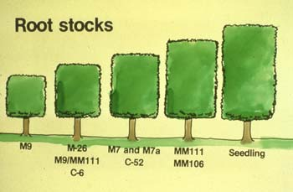
Very few fruits are propagated from seed. Because of the genetic differences between seedlings, virtually all fruit plants are produced by some form of asexual propagation in order to obtain uniformity. Rootstocks for many fruits have been developed for certain soil problems, climatic differences, and pests such as nematodes (small microscopic non-segmented worms that are parasites) and soil-borne diseases. Virtually all peaches, apples, pecans, avocados, citrus, and many other fruits are propagated and grown on special rootstocks rather than on their own roots. For example, oranges are commonly grown on sour orange, rough lemon, trifoliate orange, Cleopatra mandarin, Carrizo citrange, or some other citrus rootstock based on the soil, climate, or other considerations. Apples are grown on standard or dwarfing (size controlling) rootstocks depending on the management plan for the orchard.
Dwarfing rootstocks have been a valuable addition to the production apples. Reduced tree size enables the producer to take advantage of simpler spraying, pruning, and harvesting techniques. Dwarfing is accomplished by using certain rootstocks. Apple rootstocks used in grafting are designated by the letters M or MM plus a number. The degree of dwarfing depends on the type of rootstock or interstem used. An interstem is just a piece of stem grafted onto a rootstock. The desired apple variety is then grafted onto a rootstock. The desired apple variety is then grafted onto the interstem.
The degree of dwarfing is determined by the length of the interstem (using less than 10 to 12 inches reduces the amount of dwarfing), soil fertility, variety size, pruning techniques, and crop size (trees grow more in years where the crop is lost because of a late frost). Some dwarfing rootstocks and interstems have the potential to keep a 40 foot tree from getting no more than 8-10 tall.
Although dwarf trees require extra care and attention, it is a practical cultural technique because dwarf trees produce earlier, require less space, produce higher yields, and have higher quality fruit that are easier to harvest.

Planting and Spacing
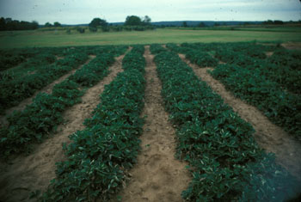
Fruit orchards are normally planted at a spacing compatible with the mature size of the plant. Strawberry fields may contain 30,000 plants per acre while pecans have as few as sixteen. Many traditional spacings are being changed to closer plantings to provide more trees per acre and thus higher yields. Dwarfing rootstocks and more intensive pruning and training are commonly used to maintain tree size and thereby permit even higher plant density. Because most fruit crops are long lived, the spacing chosen at planting will be there for years to come unless the grower removes alternate trees or rows when crowding occurs. Spacing must be wide enough to accommodate equipment used in cultivation and in harvesting the crop.
Fruit trees for planting are available as container grown or bare root plants. A few may be sold as balled and burlapped though this is a more expensive way of planting an orchard. Bare root trees are dug and sold when they are dormant and should be planted as soon as possible. Container grown trees are available year-round and may be planted at almost any time.
The planting hole should be dug larger than the longest root to allow for the entire root system. The plant should be set in the hole at the same depth or even slightly higher than it was growing at the nursery. Roots of bare root plants should be spread out in the hole. Work the soil around the roots and tamp soil lightly to remove air pockets. Water thoroughly at planting and anytime the soil dries out.
Roots of bare root plants should not be permitted to dry out at anytime from digging to planting. A good way to keep the roots moist is to place the root systems in a bucket of water during planting. It is important not to leave plants in this condition for more than a few hours, as lack of oxygen can kill roots. If plants are to be stored for several days, keep the root systems moist by covering them with moist saw-dust or mulch and keep them out of direct sunlight. Fertilization should be delayed until after new growth begins or after several rains or irrigations have settled the soil around the planting holes (several weeks).

Pruning and Training
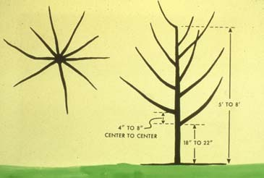
While the majority of fruit crops are allowed to grow and develop naturally, a few require extensive training following planting in order to develop the desired size and shape of the plant. Once initial training has been accomplished, subsequent pruning is necessary to maintain the desired size and shape of the plant.
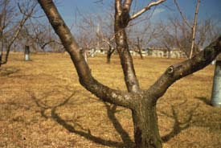
Central leader, modified leader, and open-vase are pruning/training systems used on certain fruit trees. Grapes are trained on wire trellis and there are several forms of trellis as well as pruning systems used in grape production.
Besides shape and size control, pruning is important in overall fruit production, fruit size and fruit quality. Once final plant size is attained and maintained, subsequent pruning to that size maintains fairly level fruit production from year to year. While pruning reduces the overall amount of fruit set, some crops such as peaches require additional fruit removal (thinning) in order for the remaining fruit to obtain the desired size and quality. Too many fruit on the tree can result in smaller fruit sizes and less value to the commercial grower.
Pruning is traditionally conducted during the dormant season, but more and more summer pruning is being practiced. Severe pruning of dwarf trees during the early life of the tree decreases the among of carbohydrates available to the tree. This delays fruiting and increases the size of the tree.
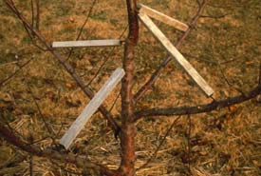
Sometimes branch spreaders are used to change the direction a branch is growing. A branch spreader is nothing more than a stick with a notch cut in each end. This stick is then wedged between two branches to increase the angle of growth. Spreaders are left in place until the branch no longer springs back. Bending branches down to a horizontal position in early summer for up to three weeks will increase flower bud formation. This can be important in getting trees to come into fruiting earlier.

Water
Most tree fruits need about 30-50 inches of water per year. This can be as rainfall or irrigation. Many areas have adequate rainfall for good growth and production. Relatively few areas have rainfall distribution patterns sufficient for optimum growth and production. Supplemental irrigation is often used even in high rainfall areas to supply water when it is needed. This reduces plant stress and increases vigor which is especially important for the development of a plant's natural defenses against insect and disease pests.
There are many irrigation systems. Each has its inherent advantages and disadvantages. The most critical issue is the capacity of a given system to apply as much water as is needed when it is needed. The crop, time of year, soil type, and climatic factors all influence the need for water. Some growers still wait for the plant to wilt before irrigating. Many growers use their years of experience to tell them when to irrigate. In many places water is too precious of a resource to be wasted.
Irrigation is also one of the major production expenses. Many growers are using computer programs that tell them when to water. The grower feeds data about the weather into the computer along with information on the condition of the crop and the amount of soil moisture. The goal is to apply water when it is needed and in the appropriate quantity, at a rate that will penetrate the soil without runoff.

Nutrition
Fruit crops are fertilized at least once and often two or more times a year. Consult local recommendations on the amount and timing of fertilizer. The rate of fertilization is based on the plant, soil, and cultural conditions. The types and quantities of nutrients is determined by soil testing and foliar tissue analysis. By the time visual symptoms of a nutrient deficiency appear, it is too late to correct the deficiency for that reason.
Fertilizer is applied in either liquid or dry (granular) forms. Liquid fertilizers are sometimes applied as foliar sprays, but most fertilizer (liquid and granular) is applied to the soil. Fertilizer can be incorporated into the soil by cultivation, rainfall, or irrigation.

Weed Control
Growers should maintain good weed control because weeds compete for water and nutrients. Mowing, cultivation, and herbicides are all used to reduce weed competition. Cultivation damages root systems and allows some evaporation of soil moisture. Mowing keeps the weeds down but leaves enough cover to prevent erosion by wind and water. Some crops and soils do better if herbicides are used to kill weeds under the trees and the middles are left in grass and mown.
Many orchards are under complete herbicide weed control to maintain a virtually weed-free condition. Competition for water and nutrients is eliminated and roots are not damaged by cultivation. A clean orchard floor provides more cold protection than a weedy situation. A clean orchard also helps in harvesting crops like almonds and pecans. These nuts are shaken from trees and then picked up mechanically.

Insect and Disease Problems
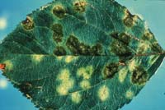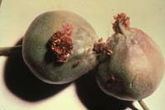
Insect and disease control are important for plant vigor, fruit quality, and yield. Most growers follow a regular spray schedule. Proper timing is as important as the material used. Air blast sprayers are generally used though hand held pressure guns are used on smaller acreages. Pesticide recommendations vary from crop to crop and from state to state. Some laws change each year. It is important to have up-to-date local information and to follow all label recommendations carefully for proper rates, frequency, and waiting time to harvest (preharvest intervals). Failure to do so can result in fines and/or prison sentences.
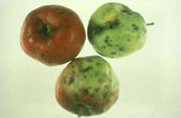
Insects may damage both fruit and trees. Fruit is damaged by both chewing and sucking insects. Even slight areas of damage may allow secondary fungal organisms to enter and cause rot and subsequent fruit drop. Damaged and scarred fruit is graded out at the packing house resulting in less income for the grower. Leaves are sometimes chewed by insects. If too much of the leaf is chewed or leaf drop occurs, the fruiting potential can be reduced. Diseases also attack the leaves, twigs, roots and fruit. Most sprays are directed toward the leaves or the fruit.
Diseases that attack the fruit are more serious because of the reduction in quality and the potential for the disease to increase in storage.

Additional Information
The diversity of fruit and nut crops grown in North America and the wide variety of soils, geography, and climate make it impossible to provide more specific information in this chapter. Your local Cooperative Extension Service office has information on varieties and cultural information for your area. They can also help you with soil samples, foliar analysis, and pest identification/control, as well as other pertinent information.

