Garden Flowers
Greg Stack
University of Illinois
Flowers offer color and form that can fit into almost any landscape. They provide color to landscapes that would otherwise be drab. Flowering plants in containers add splashes of color to decks and patios. Many types can be brought inside for fresh or dry cut flower arrangements.
Garden flowers are classified into several groups. Annuals are grown from seed and flower, produce seed and die in one growing season. Biennials complete their life span in two years. The first year they produce only vegetative growth. The second year they flower, produce seeds and die. Perennials last for three or more years. While the stems and leaves generally die to the ground with the first frost, the root system remains alive and produces more growth the following year.
The ideal way to start a garden is with a plan. This will afford a chance to arrange plants by height, color and season of bloom. A plan can be developed in many ways. An easy way is to start with height designations (low, medium, high), whether the area is to be planted in annuals, biennials, or perennials. Finally determine the season of flowering (spring, summer, fall). After determining these factors, you will want to read books and catalogs to select plants hardy to your area that fit the areas on your plan.

Soil Preparation
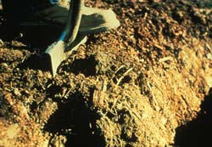
Flower gardens should be located in well drained areas. If drainage is a problem, raised beds offer an excellent way to keep the root system from being in a saturated soil. While they may not do well, annuals can tolerate poorly prepared soil if enough fertilizer and water are provided. Perennials seldom survive more than one or two years in poor soil.
If the soil is poor you can improve it by adding organic matter such as compost or peat moss. The amount will depend on the exact type of soil. Three inches of organic matter spaded in to a depth of 8 inches is a good starting place. Fall is the best time to do this so that weeds and organic matter will have a chance to decay before planting time in the spring for the northern US. The soil moisture is generally better making soil easier to work.
Fertilization
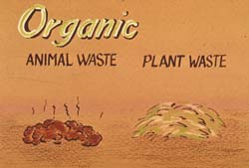
Ideally fertilizer should be added to the garden based on soil test recommendations. When this is not possible you can follow some general recommendations. Add a complete fertilizer (i.e. 5-10-5, 10-6-4, or 5-10-10) to the soil surface after the soil has been spaded or tilled and raked level. The fertilizer should be spread uniformly at the rate of three pounds per 100 square feet. This fertilizer should then be raked into the upper 2 to 3-inches of soil. Liquid fertilizer can be added in mid-summer to continue strong plant growth.
Established perennials should be fertilized in the early spring or as soon as the ground can be worked. The same type and rate of complete fertilizer can be used. Try not to get fertilizer on young perennial shoots and crowns as burning can result. A shallow cultivation will help get the fertilizer into the soil.
Perennials generally require more fertilizer than annuals and will benefit from a second application of complete fertilizer in July. Rates are the same as spring application (for additional information see the chapter on Plant Nutrition).

Selecting Plants for the Garden
There is a wide range of annual flower types. Regardless of the part of the country there is always a selection of annual flowers for the garden. Modern plant breeding and improved selection have resulted in many new varieties of old favorites that flower earlier, last longer, are more compact and offer a wider selection of colors. New introductions of annual flowers worthy of trial are designated All-America Selections (AAS). While there is no guarantee that these types of annuals will do well in your area they are worth trying.
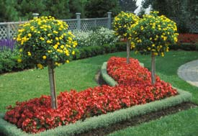
Annuals
Annual flowers are sometimes referred to as hardy or tender annuals. Hardy annuals tolerate cool temperatures and some frost. Snapdragons and larkspur are examples. These plants can be seeded outdoors very early in the spring. Tender annuals require warm soil and air and should be planted outside only after the danger of frost has passed.
Perennials
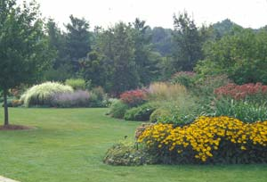
Study which perennials do well in your area before purchasing plants. Make a note of flowering season. While most perennials flower in the spring and summer, there is a great difference between different varieties of the same species. By careful selection you can have something in flower for most of the year. Select perennials hardy to your area and planting zone (see map in chapter on Environment and Horticultural Plants). Even perennials classified as hardy for your area will die if not cared for properly. Soil conditions are very important as is the need for mulch to provide winter protection. While we think of snow as being cold, it actually helps protect plants from extremely low temperatures.
Be careful in selecting rapidly multiplying perennials for small gardens. They may become undesirable additions as they rapidly take over the garden.
Biennials
A few garden flowers live for only two years. A true biennial dies after it flowers in the second growing season. Some perennials are grown as biennials because they flower poorly as they get older. Because of the short life span of these flowers, it is necessary to start some new plants every year. Examples of biennials include foxglove, hollyhock and canterbury bells.
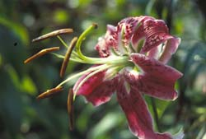
Summer Flowering Bulbs
The term bulb is used for plants that produce a variety of underground storage organs. These fleshy, below ground plant parts are important for storing plant foods and water. Not all bulbous plants produce true bulbs. A true bulb is a compressed stem with a growing point surrounded by fleshy leaves. Lilies produce true bulbs. Other bulb-like structures are called corms, tubers, tuberous roots and rhizomes.
Corms are solid with a growing point in the center. Gladiolus is one example of a corm. Tubers are fleshy stems that grow below the soil surface. Like the Irish potato, they have buds called eyes. Tuberous roots like the sweet potato and dahlia are true roots and do not have buds. Rhizomes are horizontal stems growing parallel to and at or below the soil surface. Some irises have this type of root or reproductive structure.
Among the most popular summer flowering bulbs are tuberous rooted begonia, canna, gladiolus, dahlia, iris and lily. Of these only the lily is a true bulb. With the exception of the lily and iris, these plants are not winter hardy in cold climates and must be lifted in the fall and stored until the following spring.
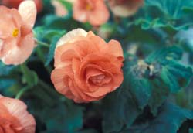
Tuberous rooted begonias are started indoors in the early spring. They can be planted outdoors in beds or pots in semi-shaded areas. They should be fertilized with a liquid fertilizer every other week during the growing season. The leaves will turn yellow in the fall. This is the time when they must be dug and stored in dry peat in a cool place.
Canna vary in height from 1-1/2 to 5 feet. They prefer a sunny location and will grow in areas that are wet. In colder climates you must dig the rhizomes after the first light frost. Trim the tops and store with soil intact in a cool dry area.
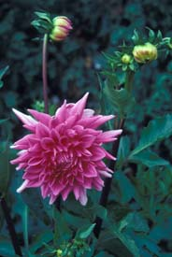
Dahlia tubers grow best in sunny locations. Varieties range from one to six feet tall and produce a variety of flower colors from 2-8 inches in diameter. Tubers should be dug after the first frost. They should be cleaned and stored in dry peat moss in a cool location. Tubers can be sprouted indoors about a month before setting out.
Gladiolus corms are planted in the spring as soon as the soil can be worked. Corms are planted 4-7 inches deep. To speed growth you should cover the corm with only an inch of soil and slowly add soil as it grows. Planting every two weeks will assure a uniform supply of flowers throughout the summer. Dig the corms after the first frost and dry for several weeks. Clean and store in a cool, well ventilated area. Onion bags make good storage containers.
Most lilies are winter hardy. Bulbs are usually planted outdoors in the fall. Bulbs are usually planted three times as deep as the bulb is tall. There are a great variety of colors, heights and flower forms.
Purchasing bulbs early insures a better selection of variety and size. Select larger bulbs to insure larger flower sizes. Avoid bulbs with mold and mechanical damage.
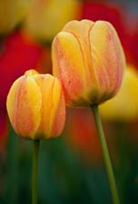
Spring Flowering Bulbs
Spring flowering bulbs are often referred to as Dutch bulbs or hardy bulbs. These include daffodils, tulips, hyacinth, crocus and hyacinth. Spring flowering bulbs look best when planted in large masses or clumps of at least six to eight bulbs.
Spring bulbs should be planted in the fall so that they will become well rooted before the soil freezes. Bulbs should be planted at the depth suggested in planting charts. As a general rule, the growing tip should be below the soil surface four times the height of the bulb. When planting spring flowering bulbs, it is important that the bulb is not twisted and pushed into the soil. This grinds off the small roots on the basal plate. When these roots do not form, the plant is unable to take up sufficient water for the leaves and flowers. The plant becomes stunted and does not develop large flowers. Spring bulbs must be grown in well drained soil that has been worked deep. Many recommendations call for the addition of bone meal in the planting hole.
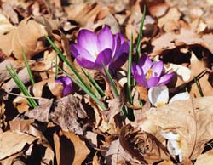
Gardeners in the deep south often have difficulty growing spring flowering bulbs because their soils do not become cold enough for plant to acquire enough chill units. Chill units are necessary for fruit trees as well as some bulbs to flower. Many distributors offer pre-cooled bulbs for markets in warmer climates. Pre-cooled bulbs should be planted as soon as possible and should not remain at room temperature for longer than five days. Gardeners can pre-cool their own bulbs by storing them for 45 to 60 days at 35-40°F. This practice will improve flower quality and length of stems. Gardeners in the deep south frequently grow spring flowering bulbs as annuals while northern growers treat them as perennials.

Growing Flowers from Seed
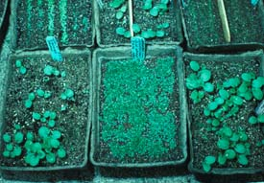
Both annuals and perennials can be grown from seed. Annual seed is fairly easy to germinate and offers the gardener a great diversity of types. Perennial seed can be more difficult to germinate. Some types of seed require special temperature treatment to insure good germination. Annual flower seeds are sown six to eight weeks prior to when they can be transplanted to the garden. As a result, timing is critical to insure that plants are in top quality. Consult seed catalogues and books for local seeding and transplanting dates.
Seed should be germinated in a prepared potting soil mix. The artificial mixes are excellent because they are well-drained, well-aerated and sterile. These qualities improve the percent germination.
Most seed should be covered with a very thin layer of the soil mix. The smaller the seed, the thinner the layer. Very fine seed like petunia is sown on the surface and lightly pressed into the soil. After sowing, the seed flat should be moistened and covered with plastic or newspaper to maintain uniform moisture. Keep the seed flat in a warm (65-70°F) location. Bottom heat is especially beneficial in promoting germination. As seeds begin to germinate, raise the cover and move the container to a bright, sunny window. Low light results in tall, spindly plants more likely to fail.
As soon as seedlings have developed their first set of true leaves they should be transplanted to individual pots or paks. As plants grow pay close attention to light, moisture and temperature. A light application of liquid fertilizer will encourage strong growth.
Annuals and perennials are kept in small pots before they are transplanted to the garden. The soil in the pot should be moist. Gently tap the plant out of the container and plant it in the loose friable soil. Do not bury the root system too deep or leave it exposed. Space between plants will depend on the growth habit of the variety. As a general rule, the space between plants should be half of their anticipated height. Stagger the plants by setting ones in the second row alternating with those in the first row. Water the plants with a transplant fertilizer. Transplant fertilizers are high in phosphorus (i.e. 10-52-17), encourage root growth and help overcome transplant shock. Follow the label directions.

Dividing Perennials
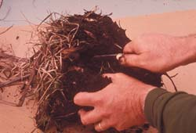
Most perennials are easier and faster to propagate by dividing established plants rather than by growing from seed. Many perennials become overcrowded and should be divided every three to four years. Plants such as peonies and lilies should not be disturbed as often.
Generally spring is the best time to divide perennials. The exceptions are peonies, iris and lilies. Bearded iris are divided in midsummer after the new growth has hardened off. Peonies are divided in late summer or early fall after new buds have formed for next year's growth.
Perennials are easily divided by digging up the clump, shaking off enough soil to expose individual crowns and tearing or cutting apart the clump. Each division should have several vegetative shoots. It is important to keep the roots moist if not replanted immediately. Replant at the same depth that it was previously growing. This is especially critical with iris and peonies. Planting too deep is a common reason these plants fail to flower.

Flower Garden Care
Mulches are used extensively in flower gardens to retard weed growth, conserve moisture and moderate soil temperature. Mulches are usually applied to a depth of about 3-inches. Piling mulch too deep can smother roots.
In cold climates, winter mulches are applied only after the soil temperature has dropped, usually after several freezes. The purpose of the mulch is to keep the soil uniformly frozen. Alternate freezing and thawing will result in heaving of plants. Once this happens the roots will dry and die. If caught early enough the plant can be gently pushed back into the soil.
Mulch should be weed free, remain loose and be easy to remove. Good mulch materials include straw, pine needles, hardwood leaves, compost, bark chips and evergreen boughs. If the mulch covers the growing points it should be carefully removed after the soil thaws but before shoot growth begins.

Cultivation, Watering and Weekly Maintenance
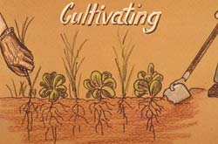
Weed control is best handled by frequent, shallow cultivation. Flower gardens should receive about 1-inch of water per week. A weekly soaking is preferred to several light waterings. Inspect the garden at least once a week. Remove unsightly plants and prune plants crowding others. Pick seed heads from plants. Most annuals and many summer flowering perennials stop flowering when they begin to set seed.
Inspect plants each week for diseases and harmful insects. Be prepared to prevent the spread of problems by removing and destroying the problem or applying recommended pesticides.

Roses
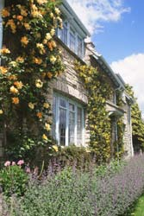
There are many types of roses available for the garden. Hybrid tea, floribunda and grandiflora are types most frequently planted. They require a vigorous disease and insect control program to keep them healthy. Shrub and species roses such as rugosa, damask, China, bourbon and Portland roses require much less attention.
Growing Conditions
Roses grow best in full sunlight but it is possible to grow them in as little as 6 hours of bright light. Morning sun is better than afternoon sun. This allows the plants to dry off quicker and prevents some disease problems.
The soil should be friable and well drained. Rose roots do not compete well with tree and shrub roots. Rose beds should be in an area where there will not be competition with other woody plants.
Selecting Plants
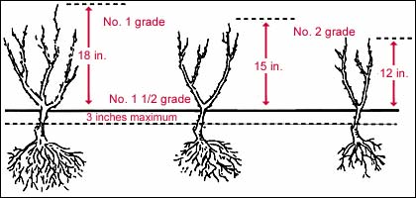
Roses are usually sold as two year old plants. They are sold by grades (1, 1½ and 2). One is the largest (best) grade. Select the best grades rather than "bargain" grades. Roses are sold as packaged plants, container grown, or bare root. Packaged and bare root roses are best bought as early in the season as possible. Container grown plants can be bought and planted at almost any time.
Planting
The best time to plant roses is dependent on the type of winter weather in your area. Where winter temperatures do not drop below -10°F either fall or spring planting is satisfactory. Spring is preferred in areas where the temperature goes below this. Rose bushes should be spaced 2½ to 3 feet apart. In subtropical climates roses have a longer growing season and should be spaced farther apart.
Planting holes should be large enough to allow full spread of the roots. This will be approximately 12-16 inches deep and 18-20 inches wide.
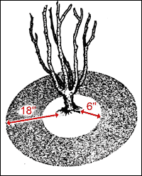
Almost all roses are budded onto a rootstock. The point where the scion (top) and stock (bottom) join is known as the bud union and forms a "knuckle." If this union is injured by cold weather the entire top may die and the roots will produce an undesirable plant. In areas where the winter temperatures are not severe, the plant is placed so that the bud union is about an inch above the soil line. In areas where winter temperatures are severe, the bud union should be about 2-inches below the soil line.
After Planting Care
Roses need water, fertilizer, winter protection and pest control. About an inch of water per week is preferred. Watering once is better than several shallow waterings. Fertilizer should be applied at the rate of three pounds of a complete fertilizer per 100 square feet. Apply as growth starts in the spring and repeat every six weeks until the end of July.
Winter Protection
Roses need protection from fluctuating winter temperatures. Proper summer care aids winter survival. A vigorous rose bush is more likely to survive cold weather than one in a weakened condition.
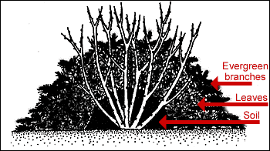
After several hard freezes, plants can be prepared for winter. A good way to protect the plant is to mound the soil 10-12 inches up around the canes. Bring soil in rather than scraping soil up from around the base of the plant. Loose friable material such as straw, hardwood leaves, compost, bark, or evergreen boughs can be used in place of soil. Rose cones can also be used. Be sure to allow for good ventilation under cones so that the inside will not heat up on bright winter days. Coverings should be removed in spring after danger of severe frost has passed. Do not be too anxious as new shoots are tender and will be damaged by late freezes.

