State 4-H Horse Show
Contestant Packet
August 29-30, 2020
Registration deadline: August 11, 2020
Heartland Rodeo Grounds, Huron SD
Erin Thelander, SDSU Extension 4-H Agri-Workforce Coordinator erin.thelander@sdstate.edu, 605.688.4167
Amanda Stade, SDSU Extension State 4-H Events Management Coordinator amanda.stade@sdstate.edu, 605.688.4167
In This Packet:
- Exhibitor Information and Reminders
- State 4-H Horse Show Schedule
- Frequently Asked Questions
- Entry Worksheet
- Youth in Action Team Entry
- My Horse Show Schedule

This packet is provided to help you prepare for the event. All class and contest rules for the State 4-H Horse Show can be found in the South Dakota 4-H Horse Project Show Guide available on extension.sdstate.edu. Good luck!

Entry Process
- Horse Show entries are due August 11, 2020.
- Youth may enter a total of 4 classes at the State Horse Show, Youth In Action classes do not add into this number. Participants can enter in as many YIA classes as they want. Return applicable fees and Fair Entry Invoice to the State 4-H Office (SAG 109, Box 2207E, Brookings, SD 57007):
  - Each Equitation, Showmanship, and Performance event is $5.
  - Registration is NONREFUNDABLE.

Entering the Fairgrounds
- Exhibitors and horses may enter the Rodeo grounds no earlier than 8:00 am central time at the start of each show day.
- Horses will not be allowed to enter the rodeo grounds without a valid Certificate of Veterinary Inspection (CVI or “health certificate”).
- Upon arriving a State 4-H Horse Show representative will inspect the trailer and review the CVI before horses can be unloaded.

Horse Stalling
- Stalling will not be provided by either the Heartland Rodeo Grounds or The State Fairgrounds

Camping Facilities
Camping will not be allowed.

Other Show Information
- No bicycles, scooters, or dogs allowed in the show arena areas during the State 4-H Horse Show.
- No smoking in the barns.

Horse Show Exhibitor Check-in
- Exhibitors must check-in upon arrival to the Replace with: Heartland Rodeo Grounds. Upon entry a member of the State Horse Committee will meet them at their vehicle to assist with check in.
- CVIs must be ready upon arrival to the grounds
- At check-in exhibitors will receive:
  - South Dakota State 4-H Horse Show Program
with show/class order and show patterns
  - Contestant Back Tags and Safety Pins
- Exhibitors within the class order are chosen at random. There are no elective classes. Contestants are NOT allowed to move to a different class within the same event. Changes to class order will ONLY occur at the time an exhibitor or horse is physically in another class during the time the exhibitor must enter the ring.
- Any issues with scheduling must be addressed to the show arena announcer at the time the conflict occurs. Order changes can only be made one class prior to the conflict or while the class is in progress. No changes to order can be made once the class is complete and the exhibitor will forfeit the run.

Riding Safety Rules
Riding safety rules will be strictly enforced at the South Dakota State 4-H Horse Show. 4-H members who violate these rules may be disqualified.
- Riding MUST occur in the designated warm up or show arenas.
- It is strongly recommended that participants wear helmets.

Horse Youth-In-Action Events
State & National Youth-In-Action Eligibility
- Speech and Demonstration contests for seniors will be held at the state horse show. No other YIA contests will be there. The remaining contests will be moved to a virtual format. An in person Horse Judging contest at a later date is in the works
- Contestants (including team alternates) that have participated in the respective national contest are not eligible to compete in the South Dakota State 4-H Contest again with the exception of Horse Judging and Hippology, addressed below.
  - Example: Once a youth participates at the National Horse Quiz Bowl contest they are ineligible to compete in the SD State 4-H Horse Quiz Bowl contest.
  - Youth in Horse Judging and Hippology will be
allowed to continue competing for individual awards after competition at the national contests.
  - The team members must be Seniors to
compete in national contests. If the winning team does not consist of all seniors, the team will be replaced with the next team.
  - The Hippology team members must be Seniors to
compete in national contests.
- State 4-H Horse Judging Contest (If in person)
  - Patterns will be posted prior to the contest and distributed during contest orientation.
  - Official placings with reasons will be given
following the contest.
- State 4-H Horse Public Speaking and Demonstration Contests
  - Seniors will be able to compete in person at the State 4-H Horse Show, beginners and juniors will be offered a virtual alternative.
  - Contestants must sign up for a presentation time in the South Dakota State 4-H Horse Show Office.
  - Scheduled times are on a first come, first serve basis. If there are any scheduling conflicts due to participation in other events, they must be addressed in the show office.
  - A computer, projector, easel, speaker podium, and tables will be available in the contest room for contestants to use as needed.
All results will be posted on extension.sdstate.edu following the State 4-H Horse Show. Posted results are final.

Photographer
- A photographer will be available to picture horses.
Exhibitors may purchase pictures at own expense.
- All class winners will be pictured and posted on extension.sdstate.edu. Photos of class winners are available to download for free.

Severe Weather Protocol – State 4-H Horse Show
All persons are responsible for their own safety!
SEVERE WEATHER/TORNADO/STORM/
LIGHTENING
- Stay tuned to your communications device for the progress of any potentially damaging weather conditions.
- In the event threatening weather is evident or a watch has been issued, check your immediate area to ensure that doors, windows and objects that may become airborne by high winds are secure.
- If a storm/tornado warning is issued, seek shelter in a brick structure. Direct all persons inside brick buildings.
- Remain in the Shelter area until an “all clear” signal is given or you are given other specific directions.
On-grounds Shelters
In the event of severe weather, all people are encouraged to seek shelter and go to the NEAREST BRICK STRUCTURE or other appropriate building on grounds. STAY AWAY FROM TIN WALLED RESTROOMS, OPEN SPAN BUILDINGS AND WOOD
BUILDINGS. Shelters on the rodeo grounds are identified on the map by a red square.
In the case of a natural or technical event, emergency information may be obtained through a variety of methods including:
- Radio
1. KOOL | 98.3 FM | (605) 996-1100 | Mitchell
2. KIJV | 1340 AM | 605 352-1933 | Huron
3. KOKK | 1210 AM | (605) 352-1933 | Huron
4. KJRV | 93.3 FM | (605) 352-1933 | Huron
5. KDLO | 96.9 FM | (605) 886-8989 | Watertown
6. WNAX | 570 AM | (800) 367-9629 | Yankton
- Television
- KSFY (ABC)
- KELOLAND (CBS)
- KDLT (NBC)
C. The State Fair public address system (when State Fair staff is on-grounds)
Additional Resource Telephone Numbers:
- Aberdeen Weather Service
National Weather Service (covers Beadle Co)
  - 225-5547 or (605) 330-4247
- Huron Fire Department
  - 353-8520
- Huron Police Department
  - 353-8550
- Beadle County Sheriff
  - 353-8424
- Huron State Radio
  - 353-3527
- Beadle County Emergency Management (605) 353-8421
4-H State Horse Show Schedule

Saturday (8/29)
Arena 1 and 2 will be the large arena at the rodeo grounds divided in half.
“Full Arena” refers to the same arena when it is not divided.

Arena 1 (Starting at 10:00a.m. central time)
Showmanship-
Sr. Western
Sr. English
Beg. Western
Beg. English
Equitation-
Sr. Hunt Seat
Beg. Hunt Seat
Sr. Stock Seat
Beg. Stock Seat

Arena 2 (Starting at 10:00a.m. central time)
Showmanship-
Jr. Western
Jr. English
Sr. Draft
Jr. Draft
Equitation-
Jr. Hunt Seat
(Change Break)
Jr. Stock Seat

Full Arena (Starting after the completion of the classes above)
Driving Practice (half hour)
Sr. Single Horse Pleasure Driving
Jr. Single Horse Pleasure Driving
Sr. Team Pleasure Driving
Jr. Team Pleasure Driving

Sunday (8/30)
Full Arena (Starting at 10:00a.m. central time)
Sr. Reining
Jr. Reining
Sr. Ranch Riding
Jr. Ranch Riding
Beg. Pole Bending
Beg. Pony Pole Bending
Jr. Pole Bending
Jr. Pony Pole Bending
Sr. Pole Bending
Beg. Barrel Racing
Beg. Pony Barrel Racing
Jr. Barrel Racing
Jr. Pony Barrel Racing
Sr. Barrel Raci

Heartland Rodeo Grounds

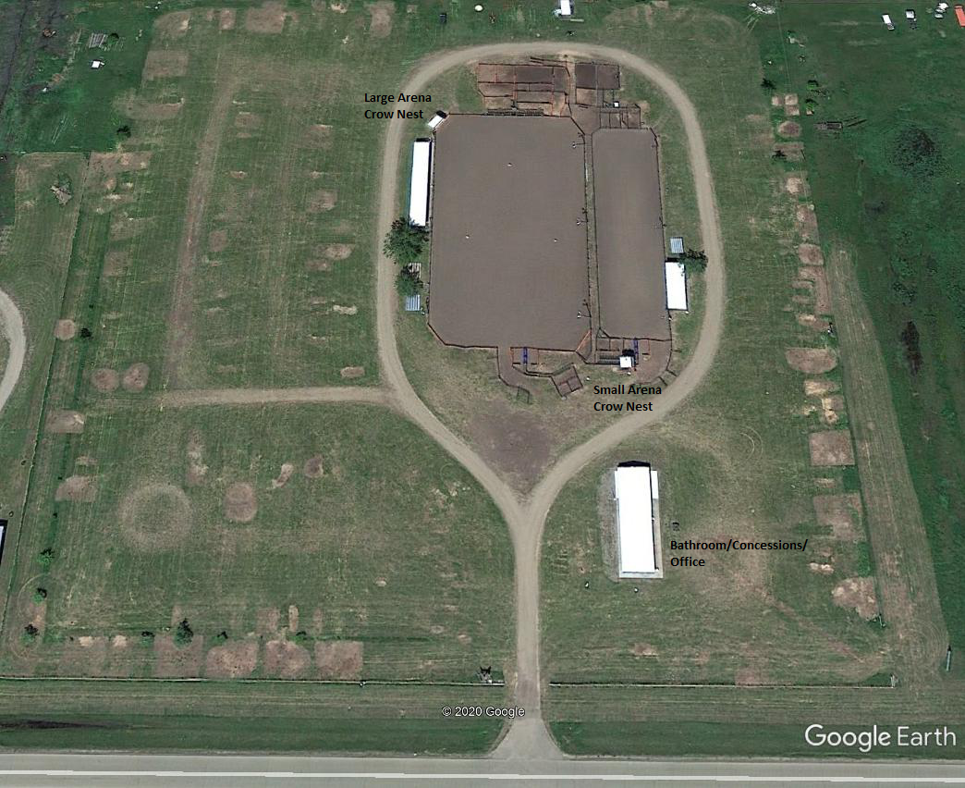

What is a health certificate or CVI and why is it needed at the State 4-H Horse Show?
Horses used for exhibition must be examined by an accredited veterinarian no more than 30 days prior to the State 4-H Horse Show and receive a Certificate of Veterinary Inspection (CVI) stating the animal is free of signs of infectious or contagious diseases. CVIs are turned in at the State 4-H Horse Show Office and collected by the South Dakota Animal Industry Board. This biosecurity measure helps lower the risk of spreading disease between horses and ensures a safer environment for horses and exhibitors participating.
Will a veterinarian be at the State 4-H Horse Show? In case of emergency, local veterinarian contact information will be made available to State 4-H Horse Show Exhibitors. A veterinarian is not guaranteed to be present during the entirety of the State 4-H Horse Show.
Does a horse have to be housed in a State 4-H Horse Stall while on the fairgrounds?
This year there will not be any stalling at either the rodeo grounds or the fair grounds. This is due to the change in location as well as to encourage social distancing and reduce the number of people in a confined area. The fairgrounds cannot accommodate us and still set up for the livestock show.
Can a companion horse, not used within the State 4-H Horse Show, enter the fairgrounds? YES. The horse must be listed on the health certificate to enter the fairgrounds.

When and where can an exhibitor practice riding? Are there specific times to practice an event? There will be a separate warm up arena that will be open during the duration of the show. There will be times when it is reserved exclusively for driving warm ups.
Can an exhibitor’s horse trainer ride their horse at the State 4-H Horse Show?
NO. 4-H exhibitors are expected to care for, groom, and ride their horses while at the State 4-H Horse Show. Only the 4-H member, a member of the immediate family, fellow 4-H member, or 4-H Club leader may perform the fitting or ride a 4-H exhibitor’s horse.
Is there an area to wash and groom horses at the State 4-H Horse Show?
There are hydrants available but there are not formal wash racks on the grounds.
How does an exhibitor know when their class is in the ring?
Each exhibitor will receive an exhibitor packet when they check in at the State 4-H Office that contains the show schedule and class order. It is the responsibility of the horse show arena announcer to announce classes. Announcements are also made on the fairgrounds PA system. When time permits, announcers at their discretion may make announcements to update exhibitors in the class make-up and barn areas concerning the progress of the classes in the arena(s). Exhibitors and exhibitor’s parents/guardian are responsible for keeping track of class orders and for being in line or in the makeup area when their run or class time arrives.
Where does an exhibitor line up with their horse to enter a class?
Each show arena has a make-up area outside the arena entry gate. Exhibitors need to report to this area when their class is called. For all “individual go” classes, there will be an “on-deck” cone prior to the entry gate of the arena. It is the responsibility of each exhibitor to be at the on-deck cone at the required time to be checked in prior to entering the ring. In all other classes, the gate will be closed when the last visible horse in make-up area for that class enters the ring. No additional entries will be accepted to that class.
What happens if an exhibitor’s class is in the ring and the exhibitor or horse is showing in a different ring at the same time?
One-two rings will be used concurrently during the State 4-H Horse Show. Efforts have been made to eliminate or minimize class conflicts between the rings. In cases of conflicts, however, the show management will cooperate wherever possible to allow youths to participate in conflicting schedules if notified at the time the conflict occurs. Show management may authorize an exhibitor to move to the next class in the order-of-go. An exhibitor or parent/guardian should report to the arena announcing stand once class prior to the conflicting class or while the class is in progress to request the class change. No changes to order can be made once the class is complete. Please note: Entry fees will not be refunded to youths who miss a class due to scheduling conflicts. There are no class holds for tack changes.
What happens if an exhibitor misses their class? Exhibitors who miss their class or run will forfeit their run in that class. An exhibitor may only participate in the
next class order if the exhibitor or horse was physically showing in another arena and show management was notified prior to the end of the missed class.
Is an exhibitor allowed to talk to the State 4-H Horse Show Judge?
At no time should the exhibitor and/or parent/guardian confront the judge before or during the show. Exhibitors and/or parent/guardians may be allowed to contact the judge following the completion of the show at the discretion of show management. Reasons will be given in every event following the awards within an event. This will allow youth to understand the criteria the youth were judged on and allow the judge to explain his/her placing. Judge’s decisions are final.
Where does an exhibitor go if they have any questions or concerns and who do they talk to?
Exhibitors should report to the State 4-H Horse Show Office Show office management will direct the exhibitors question to the appropriate individual. The South Dakota 4-H Youth Development Program reserves to its Executive
Committee from the South Dakota 4-H Horse Advisory
Council the final and absolute right to interpret the South Dakota 4-H Horse Project Show Guide rules and regulations and to arbitrarily settle and determine all matters, questions and differences in regard thereto, or otherwise arising out of or connected with or incident to the Show, and the right to amend or add to these rules as its judgment may determine.
Do the Grand Champions receive a photograph after the event as part of their award?
No, the State 4-H Office contracts with a photographer to take pictures during the show. They will take a picture of the Top 5 in each event; this picture will be posted on extension.sdstate.edu and will be available for free download. No individual pictures are produced and sent to the exhibitor as part of their award.
When will State 4-H Horse Show patterns be available? The patterns to be used at the State Horse Show will be published on extension.sdstate.edu by July 1st.
What do I do once I get to Huron for the horse show?
- Enter the Heartland Rodeo Grounds
- Your horses will be inspected to ensure their descriptions match those on your CVI.
- Participants will receive a show packet, including the program with order of go and participants show number.
  - Your back number must be attached to your back, unobstructed by hair, or on both sides of your saddle pad.
  - Pins will be included.
- Youth may use the designated warm up ring for practice. The main show ring will also be available prior to the show until it is cleared by show management.
  - Be respectful of those lunging.
- When your class is called, check in at the arena at least 4 exhibitors before your turn. Order of go can be found in your Horse Show Program in your contestant envelope at the Horse Show.
  - If you have a class conflict in another arena, let the ring staff know as soon as possible.
  - If you are not present when your turn is called, you may be disqualified. Please pay attention to your ring.
- Awards will be distributed to counties at a later date.
- Be sure to check in for Youth in Action events within the allotted registration time.

Entry Codes for Fair Entry
Lot | Performance
3000 | Junior Reining
3001 | Senior Reining
3002 | Junior Ranch Riding
3003 | Senior Ranch Riding
3006 | Junior Pleasure Single-Horse Driving
3007 | Senior Pleasure Single-Horse Driving
3008 | Junior Team Hitch Driving
3009 | Senior Team Hitch Driving
Lot | Timed Performance Events
4000 | Junior Barrel Racing
4001 | Junior Pony Barrel Racing
4002 | Senior Barrel Racing
4003 | Junior Pole Bending
4004 | Junior Pony Pole Bending
4005 | Senior Pole Bending
Lot | Youth in Action
5000 | Junior Hippology Team 1
5001 | Junior Hippology Team 2
5002 | Senior Hippology Team 1
5003 | Senior Hippology Team 2
5004 | Beginner Horse Judging
5005 | Junior Horse Judging
5006 | Senior Horse Judging
5007 | Public Speaking Contest
5008 | Individual Demonstration
5009 | Team Demonstration
5010 | Horse Quiz Bowl Team 1
5011 | Horse Quiz Bowl Team 2
Lot | Showmanship
1000 | Beginner Western Showmanship
1002 | Junior Western Showmanship
1004 | Senior Western Showmanship
1005 | Beginner English Showmanship
1006 | Junior English Showmanship
1007 | Senior English Showmanship
1008 | Junior Draft Horse Showmanship
1009 | Senior Draft Horse Showmanship
Lot | Equitation
2000 | Beginner Stock Seat Equitation
2001 | Junior Stock Seat Equitation
2002 | Senior Stock Seat Equitation
2003 | Beginner Hunt Seat
2004 | Junior Hunt Seat Equitation
2005 | Senior Hunt Seat Equitation
The following will be the official classes at the 2019 State 4-H Horse Show. Exhibitors should enter classes within their age division whenever possible. A senior exhibitor may compete with a pony in any senior division event. A senior contestant may also use a miniature horse in western showmanship.
4-H Exhibitor Directions:
- Use the following Horse Entry Codes to register for 2019 State 4-H Horse Show.
- Write the lot number and name on the South Dakota 4-H Horse Show Horse Entry Worksheet.
- Write the name of the horse that will be used within the class.
- Each class has a $5 entry fee due August 11 to the State 4-H Office. Fees must be remitted at this time to be eligible to compete. Entry fees are nonrefundable.
- Additional Stock Fees will be charged for roping events.

Entry Worksheet
4-H Exhibitor: This is not an official entry document.
Exhibitors must have all entries and fees turned in to the State 4-H Office by August 11, 2020 Send this document with your receipt from FairEntry to State 4-H office with your payment.
Showmanship, Equitation, and Performance events are $5 per youth per event.
Make checks payable to:
State 4-H Office – Horse Show Entry
Mail Entries to:
State 4-H Horse Show Entry SAG 109, Box 2207E Brookings SD 57007
Exhibitor Name: _________________________________________________ County: ___________________________ Age Division: As of January 1, 2020  Beginner  Junior  Senior
Parent/Guardian Name: ___________________________________________ Phone Number: ____________________
 | Entry fees due
Total # of entries: |  | Entry Fee | Total
Horse Events |  | $5 Per Event
 |  | Total Entry Fees =

Youth in Action Entry
Please complete and send to your County 4-H Office by July 1.
Your county’s 4-H Youth Program Advisor will send one list of all county teams to the State 4-H Office.
 | Horse Youth in Action
Horse Judging Contest | Hippology | Horse Quiz Bowl
Team Name: | Team Name: | Team Name:
Team Members’ Names: | Team Members’ Names: | Team Members’ Names:
1 | 1 | 1
2 | 2 | 2
3 | 3 | 3
4. | 4. | 4.
Public Speaking Contest
Presentation Title:
Individual Demonstration Contest
Presentation Title:
Team Demonstration Contest
Presentation Title:
Partner:

This page is included to help you organize your State 4-H Horse Show experience.
Keep this page for your use.
 | My Horse Show Schedule
Event | Day | Time | Ring | Horse’s Name
Example: Western Showmanship | Monday | 10:00 AM | Arena A | Frank
SDSU Extension is an equal opportunity provider and employer in accordance with the nondiscrimination policies of South Dakota State University, the South Dakota Board of Regents and the United States Department of Agriculture. MC-00411

