***SD CDM Skill-a-thon Sewing and Clothing ID***

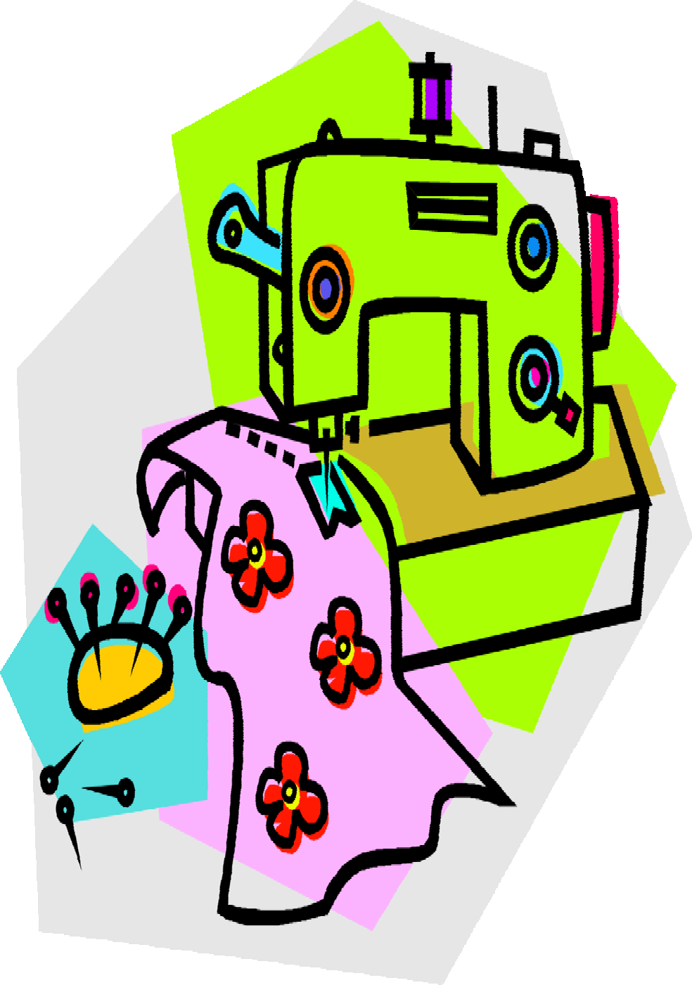

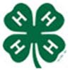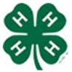**The photos shown here are only one option of what**

**an item may look like.**

**Updated February 2020**

# Fabrics

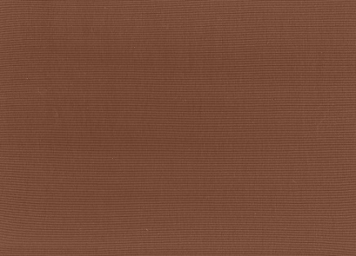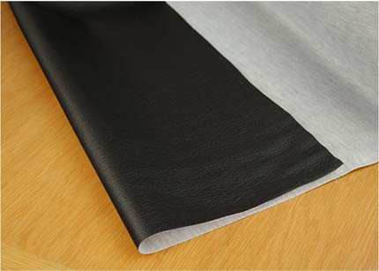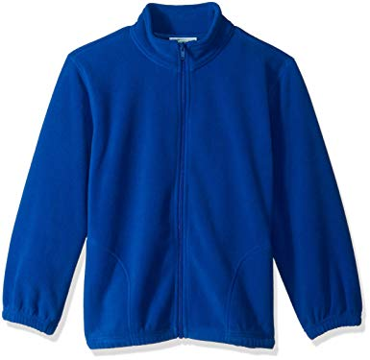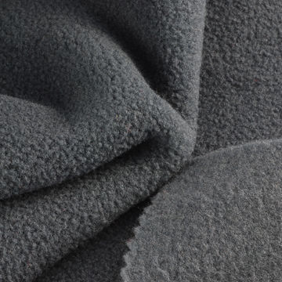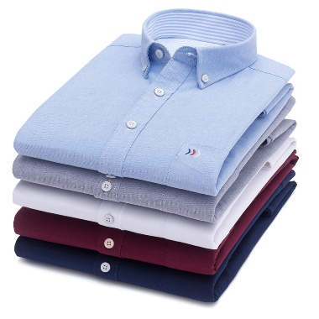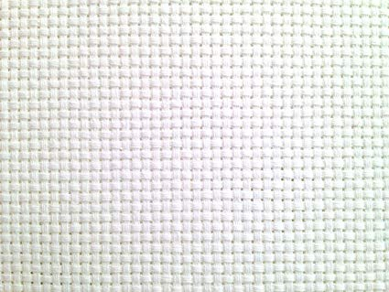

**Faux Leather –** Artificial leather is a material intended to substitute for leather in fields such as upholstery, clothing, footwear, and fabrics and other uses where a leather-like finish is required but the actual material is cost-prohibitive or unsuitable.

**Fleece –** Fabric with a soft deep pile.

**Cotton –** Good material for first time sewers to use. Has a good hand and little elasticity. Considered a heavy weight material. Used for everyday clothing.

**Aida Cloth –** Beautiful even-weave cloth, popular for cross stitch work, crewel embroidery, and other stitchery.

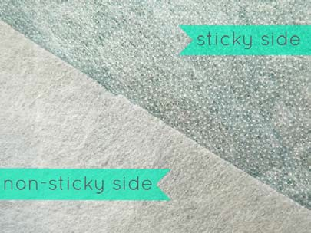

**Iron On Interfacing –** Used to add stiffness to fabric. The interfacing you’ll find in a craft store today is fusible and is applied to the wrong side of the fabric.

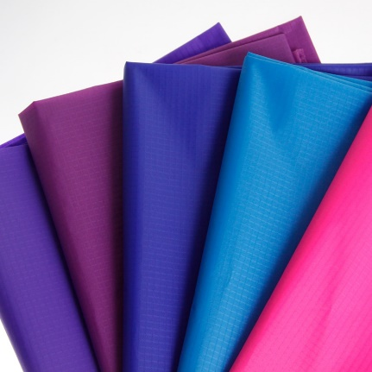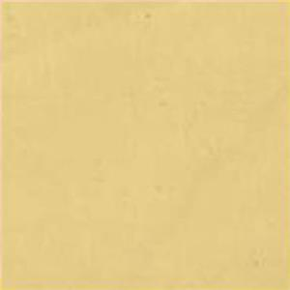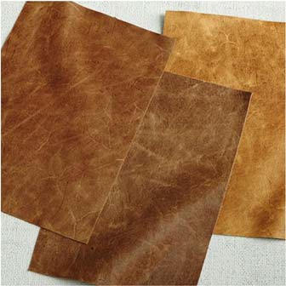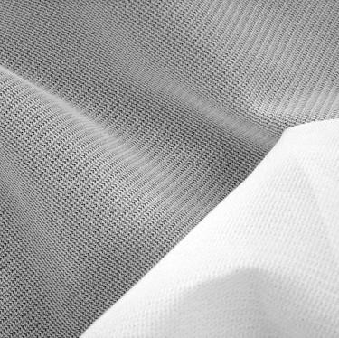

**Leather –** A durable and flexible material created by tanning animal rawhides, mostly cattle hide. It can be produced at manufacturing scales ranging from cottage industry to heavy industry.

**Nylon –** Nylon is a synthetic material widely used for textiles. It has great strength, toughness, and elasticity. A variety of everyday objects are made of nylon such as umbrellas, kites, coats, ropes, and stockings.

**Muslin, Unbleached –** Sturdy cotton fabric of plain weave, used especially for sheets.

**Knit Interfacing –** A supple stabilizer for dresses, jackets, and pants. It is best used with light to midweight knits, wovens, sweater knits, and machine knitted fabrics and is excellent with fabrics such has wool, flannel, and gabardine.

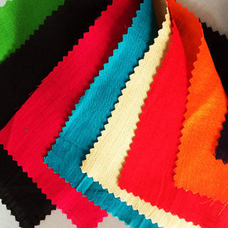

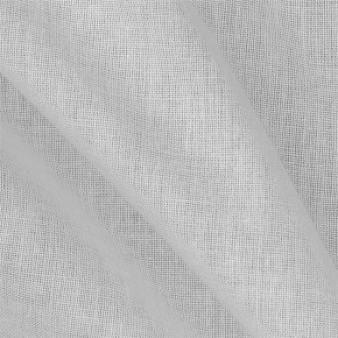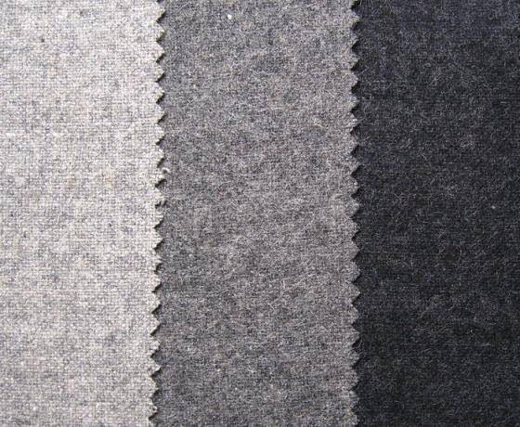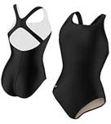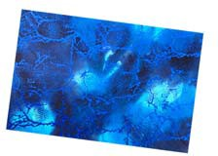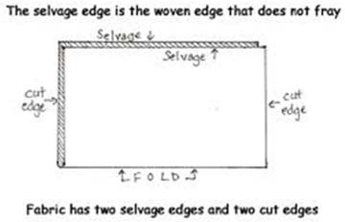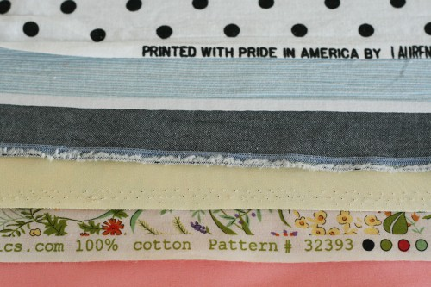

**Woven, Fusible Interfacing –** It provides crisp support for collars, cuffs, yokes, pockets, facings, and other detail areas of a garment. It can also add body and permanent stability when used as a backing for needle work and punch embroidery.

**Wool –** A rough fiber with good crimp. Has a stiff drape and good cover. Used in carpets and some clothing.

**Spandex –** A strong fiber with medium weight and good elasticity. Used for clothing and swimsuits.

**Rayon –** Rayon is a manufactured fiber made from regenerated cellulose fiber. The many types of grades of rayon can imitate the feel and texture of natural fibers such as silk, wool, cotton, and linen. Known as artificial silk.

**Selvage –** Uncut edge on both the right and left side of the fabric as it is woven. The way it is finished makes it unsuitable for fabrications.

**Sewing Machine Parts**

**Please match the number on the picture with the numbered definitions below.**

17. Bobbin

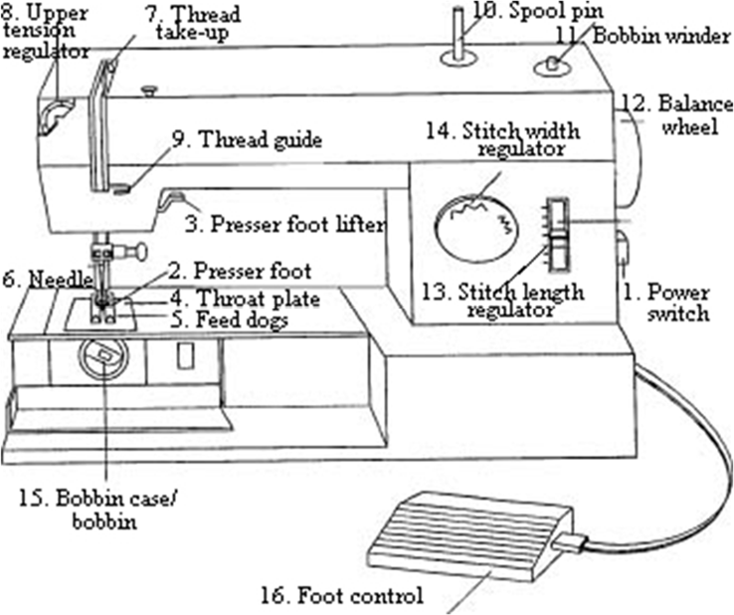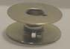

1. **Power Switch –** This switch turns the sewing machine on and off.
2. **Presser Foot –** The presser foot holds the fabric in place during sewing. The presser foot must be lowered before you begin to sew, or fabric will not move through the machine.
3. **Presser Foot Lifter –** The presser foot is used to hold the fabric down to the needle plate so it can be sewn smoothly. When you sew, the presser foot should be down; when you’re done sewing, lift it up with the presser foot lifter**.**
4. **Throat Plate –** The throat plate is a metal plate with openings for the needle and the feed dogs.
5. **Feed Dogs –** It is the part under the needle plate, where the teeth are used to move it forward. It is the feeder mechanism which his typically used to pull fabric through a sewing mechanism.

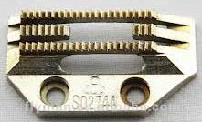

1. **Sewing Machine Needle –** A sewing machine needle consists of: shank – clamped by the sewing machine’s needle holder; shoulder – where the thick shank tapers down to the shaft; shaft – a length suitable for driving the eye and thread through the material and down to the bobbin; groove – cut in the back of the shaft to release the thread into a loop that aids the hook or shuttle to pick up the thread; scarf – provides extra room for the hook or shuttle to pass close by; eye – carries the thread; and point – penetrates the material by parting the threads or cutting a hole.
2. **Thread Take Up –** The take up lever is used in threading the sewing machine and to keep the thread tension at the proper level. If the take up lever is threaded improperly, the thread will knowt up and jam in the machine.
3. **Upper Tension Regulator –** A sewing machine feature that sets the balance between the bobbin and needle threads. On some sewing machines the tension has one permanent setting. On other machines the tension can be set or adjusted according to the type of fabric.
4. **Thread Guide –** Part of the upper threading sequence, they direct the flow of thread to keep the thread going straight in one direction.
5. **Spool Pin –** Holds the spool of thread.
6. **Bobbin Winder –** On a sewing machine it is a device that winds bobbins.
7. **Balance Wheel –** The balance or hand wheel is used when you want to manually move the needle up and down. The hand wheel can be pulled out when you want to disengage the needle (run the spool of thread without the needle going up and down). The hand wheel raises and lowers the needle. You must always pull the hand wheel towards yourself to prevent tangling of the threads.
8. **Stitch Length Regulator –** The mechanism that allows you to adjust the length of your stitches.
9. **Stitch Width Regulator –** The mechanism that allows you to adjust the width of a wide stich, such as a zigzag stitch.
10. **Bobbin Case –** The bobbin case is a small case into which the bobbin is inserted and threaded, and then is inserted into the sewing machine.
11. **Foot Control –** A device which is placed on the floor rather than the table, which is stepped on. Used to apply power to the sewing machine or serger.
12. **Bobbin –** The bobbin a cylinder on which thread is would for sewing. It holds the bottom thread.

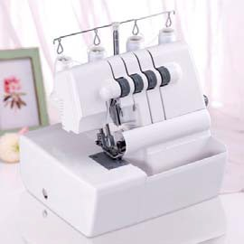

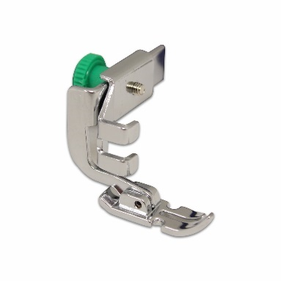

**Zipper Foot –** A sewing machine attachment that is designed for installing zippers; the design of the foot allows the needle to stitch close to different items such as zippers and cording.

**Serger/Overlook Machine –** A machine used to secure seams to prevent them from coming undone by stitching over or crossing with another seam.

**Techniques**

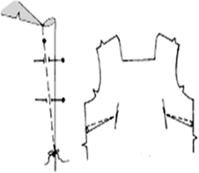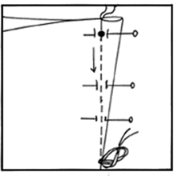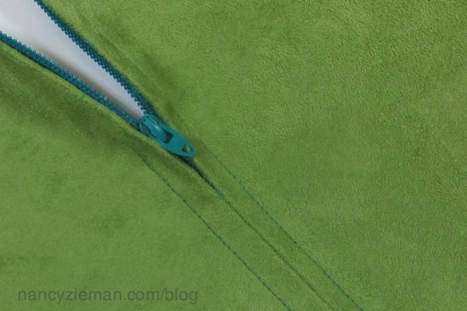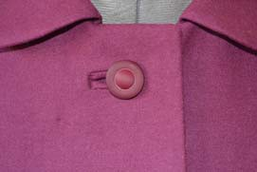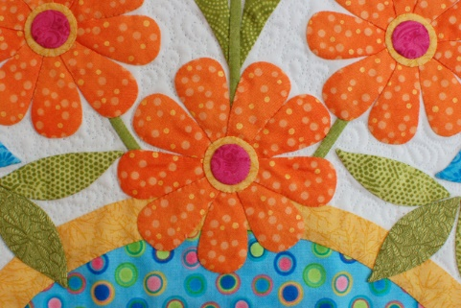

**Dart –** A tapered tuck sewn to adjust the fit of a garment.

**Center Zipper Application –** A centered zipper is a zipper that is sewn in with an even amount of fabric on each side of the zipper. The teeth of the zipper are under the area where the fabric would crate a seam if there were not a zipper.

**Applique’ -** To attach a small piece of fabric to a larger piece of fabric, to create a desired design.

**Bound Buttonhole –** This type of closure is mostly found on traditionally tailored jackets and coats, along with hand pad-stitching, back-stays, and beautiful hand stitching.

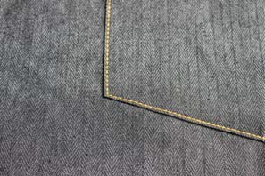

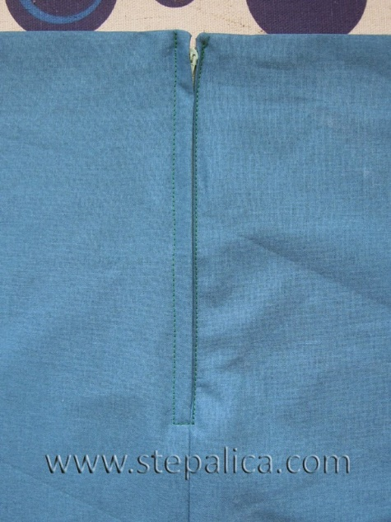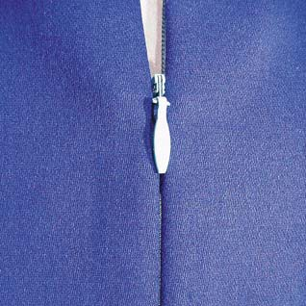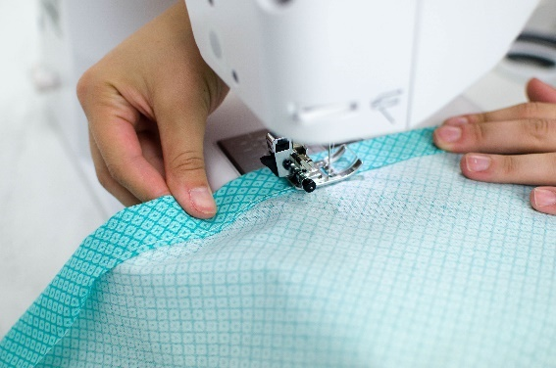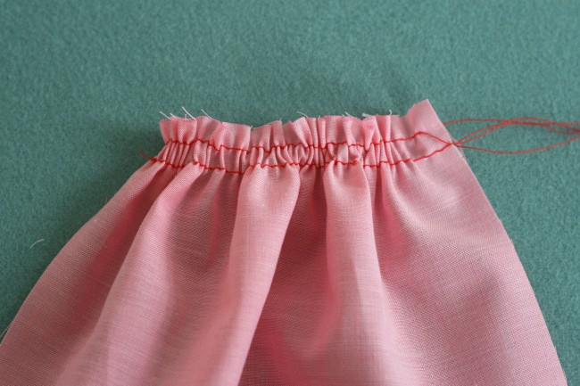

**Hidden Zipper –** A zipper that is installed in the seam of two pieces of fabric in such a way that the zipper is recessed in the seam and “invisible” as the name suggests. It is predominately used for garments, especially skirts and dresses, but it can also be found in bags and home décor items.

**Hem –** An edge or border on a piece of cloth, especially a finished edge, as for a garment or curtain, made by folding an edge under and stitching it down.

**Gather –** To draw into small fold or puckers, as by pulling a thread through cloth.

**Lapped Zipper Applications –** A lapped zipper application has one line of fabric showing on the outside with the appearance that all of the fabric is on one side. It is most commonly seen in slacks and skirts.

**Top Stitching –** Make a row on continuous stitches on the top or right side of a garment or other article as a decorative feature.

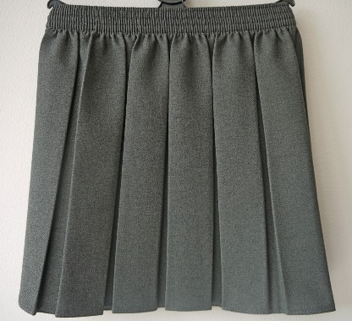

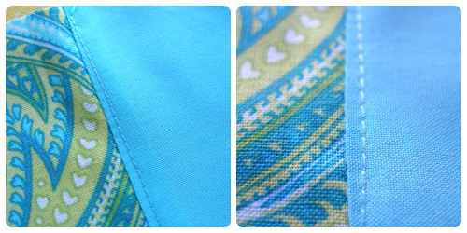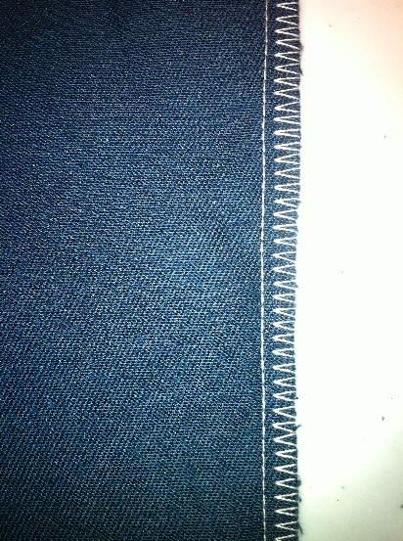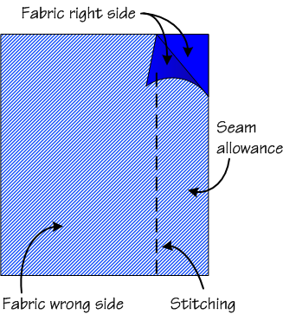

**Under-Stitching –** Under-stitching assists a facing or lining to stay to the inside and remain un-seen. It is a stitching that is sewn as close to the seam line as possible holding the graded seam allowance to the facing or lining.

**Seam Allowance –** The area between the stitching and raw, cut edge of the fabric.

**Pleat –** A fold in cloth made by doubling the material upon itself and then pressing or stitching it into place.

**Serged –** Much like backstitching your seams on a sewing machine, there are ways to secure serged seams to prevent them from coming undone. Stitches are secured when they are sewn over or crossed with another serged seam.

**Trims & Fasteners**

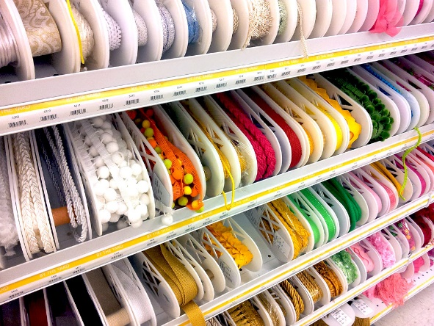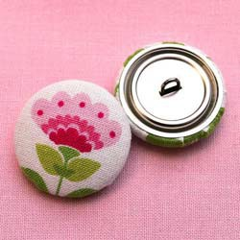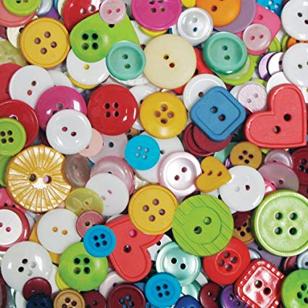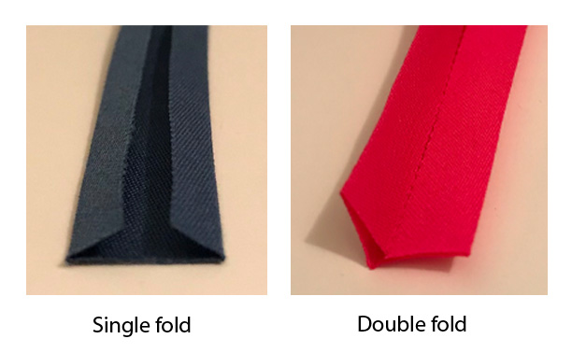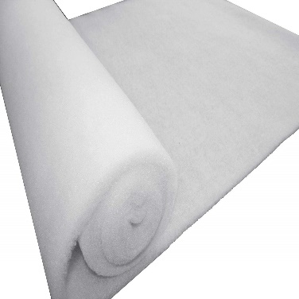

**Decorative Trim –** Trim that is used to decorate the edges of material.

**Covered Buttons –** Used for garments, jewelry, and accessories. Craft cover button kits have a mix of button backs that have shanks, and backs that are flat for a variety of DIY craft uses. Cover buttons (without teeth); for garments, and wearable and home accessories.

**Button –** A generally disk-shaped fastener used to join two parts of a garment by fitting through a buttonhole or loop.

**Batting –** Cotton, wool, or synthetic fiber wadded into rolls or sheets, used for stuffing furniture and mattresses and for lining quilts.

**Bias Tape –** Narrow strip of cloth that is cut on the bias (diagonal to the grain of the fabric) that can be used to finish or decorate clothing.

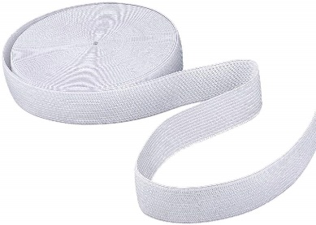

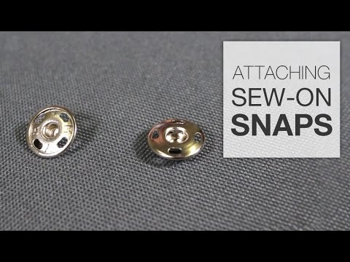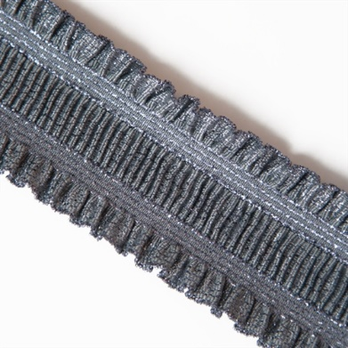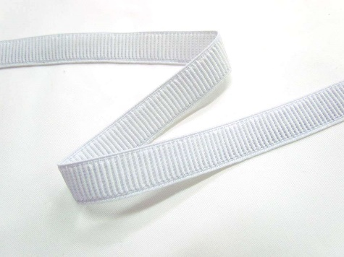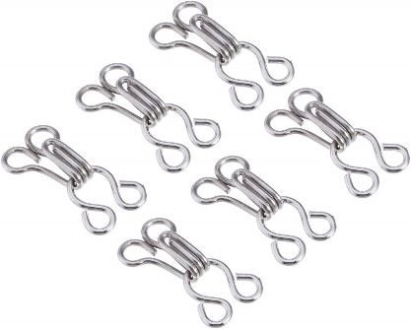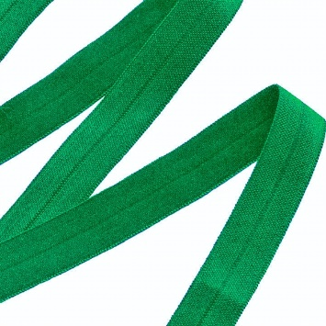

**Sew On Snaps –** Used as closures at the tops of garments.

**Ruffle Elastic –** Soft elastic with shiny, narrow ruffles on each side.

**Hook & Eyes –** Clothes fastener consisting of a small hook and metal loop. Used as a closure at the tops of shirts, dresses, skirts, or pants.

**Fold Over Elastic –** Can be used to encase the edge of a seam by folding along the center indentation.

**Elastic –** A flexible stretchable fabric made with interwoven strands of rubber or an imitative synthetic fiber.

**Ribbed Elastic –** Provides maximum cross strength Found in pants and shorts.

**Tools**

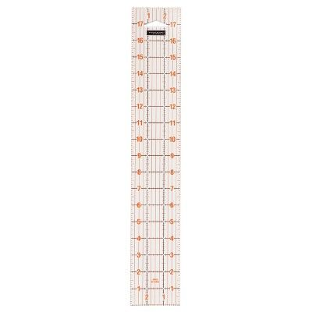

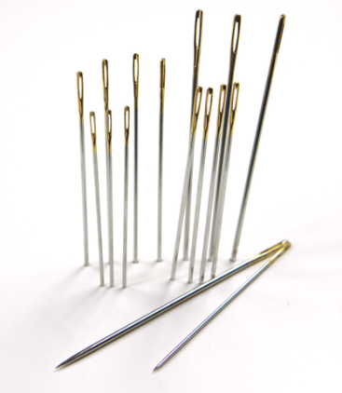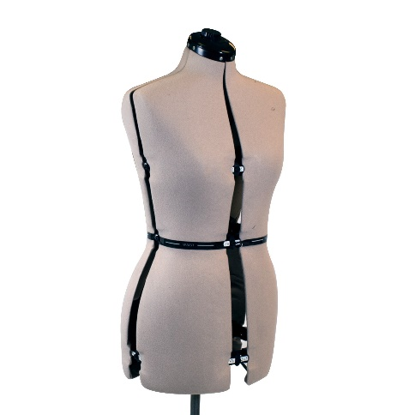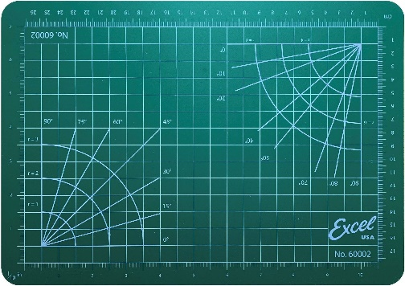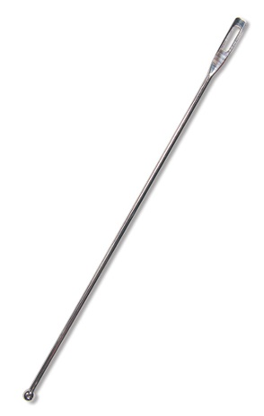

**Crewels –** Needles with long eyes for easy threading**.**

**Dress Form –** Used to help form a garment to your specific measurements.

**Cutting Mat –** Mat that is placed down to protect the table surface while cutting.

**Acrylic Ruler –** Ruler used in crafts and clothing showing different measurements. May come in different shapes and sizes.

**Ball Point Bodkin –** A sharp slender tool used to insert elastic into casings, to turn bias tubing, and to weave ribbon cording. A handy tool to use instead of a safety pin.

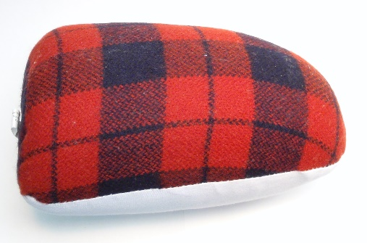

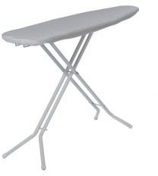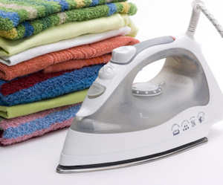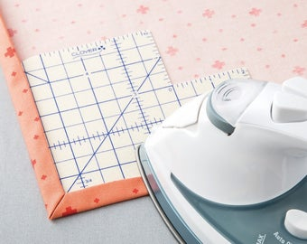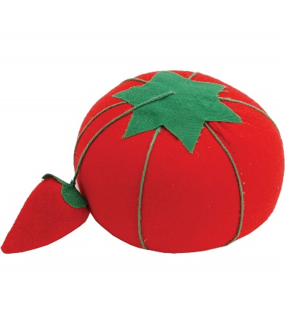

**Ironing Board –** A long, narrow padded board, often with collapsible supporting legs, used as a working surface for ironing.

**Iron –** A heated metal appliance with a handle and a weighted flat bottom that is used to press wrinkles from fabric. It has multiple settings for different fabrics.

**Emery Bag –** Used to sharpen and remove rust from needles.

**Dressmaker’s Ham –** Pressing aid used on hard to reach areas.

**Ham Guide –** The fastest, fuss-free way to hem. Heat-resistant guides allow you to simply fold the fabric along the edge and press as you go. Unlike metal pressing guides, steam is absorbed through these guides assuring a perfectly set hem.

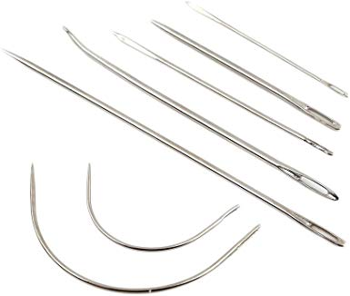

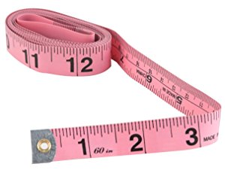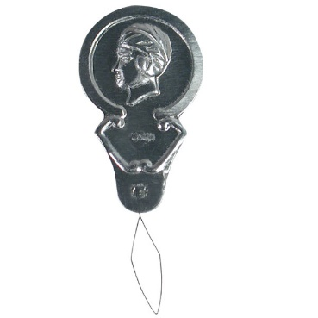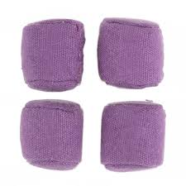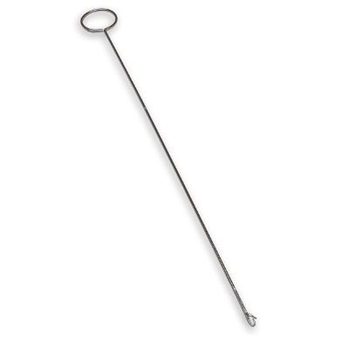

**Leather Needles –** Stitching Needles; blunt needle with an extra-large eye makes hand stitching much easier. Approximately 2” long.

**Needle Threader –** Used to thread machine or hand needles.

**Pattern Weights –** Keeps pattern pieces in place without pinning.

**Loop Turner –** Used for turning binding and inserting cord into tubing.

**Measuring Tape –** Used for measuring larger pieces of fabric and body measurements.

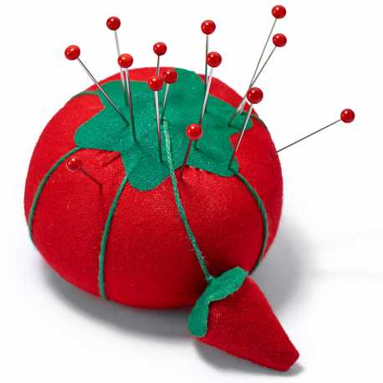

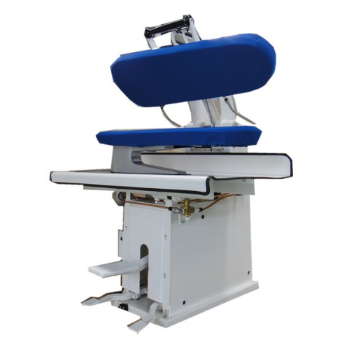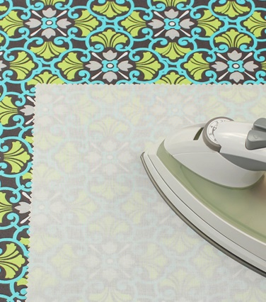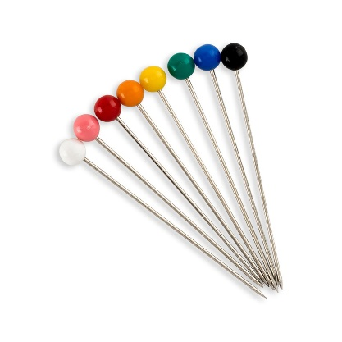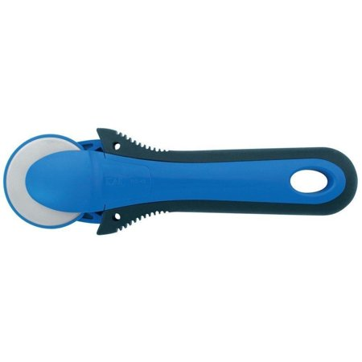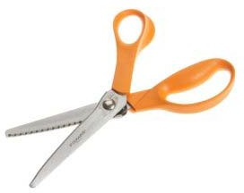

**Pressing Machine –** Used to press material.

**Press Cloth –** Used to help keep shine in fabric. Can be dampened to provide moisture for more steam. Unbleached muslin about 14”x 30” in size.

**Pins –** Fine sharp items used to hold material together while sewing.

**Rotary Cutter –** A wheel with a sharp edge that is used to cut fabric, used on a cutting mat.

**Pinking Shears –** Used for finishing seams.

**Pin Cushion –** A small cushion used for holding pins for easy access**.**

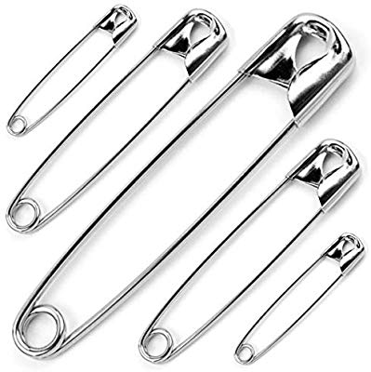

**Safety Pins –** A loop shaped pin that fastens into itself with its points under a protective cover to prevent accidental opening or injury.

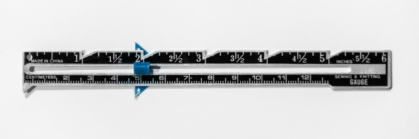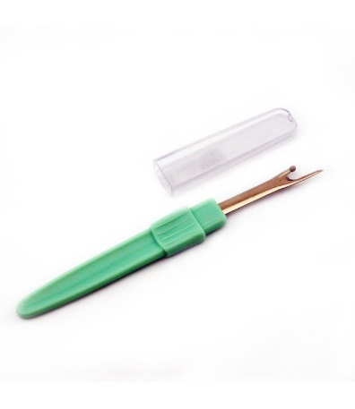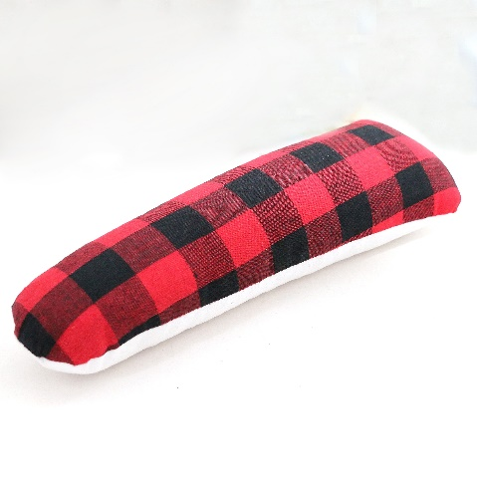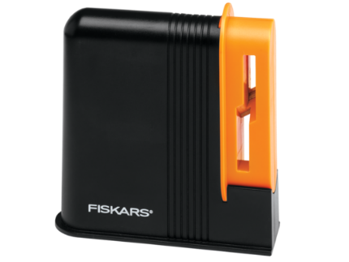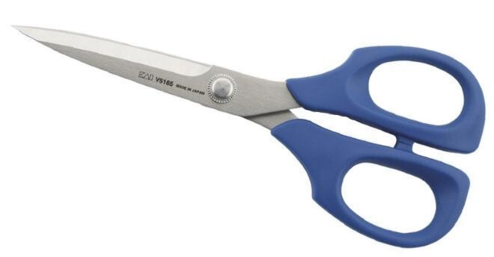

**Seam Gauge –** A short ruler that has a moveable slide for making hems, seams, and other areas.

**Seam Roll –** For pressing seams open long and narrow areas.

**Seam Ripper –** Used to take out seams as well as making buttonholes.

**Scissors Sharpener –** Re-sharpens and soothes worn blade edges.

**Scissors –** Used for cutting paper and clipping fabric. Scissors may have straight handles.

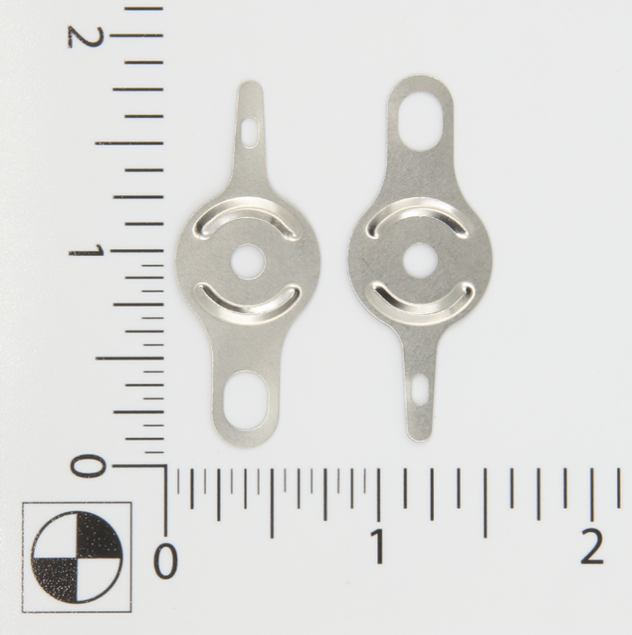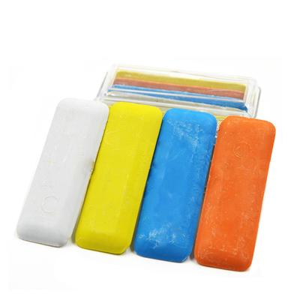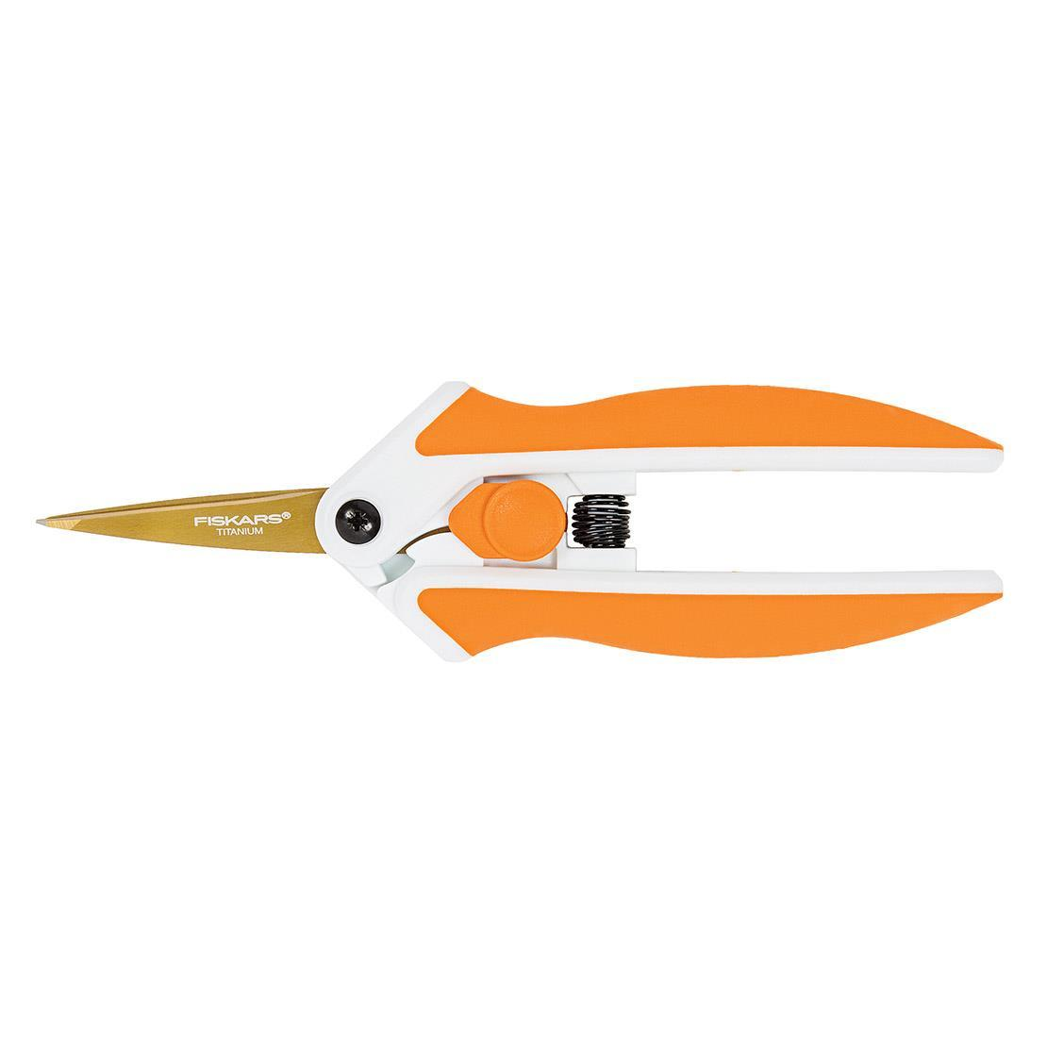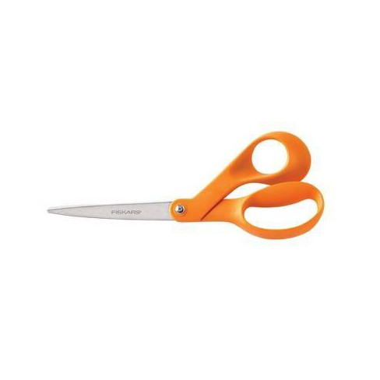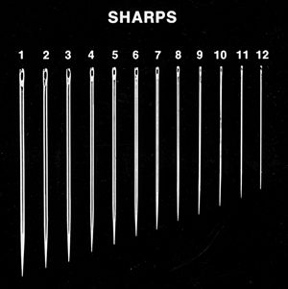

**Tapestry Needle Threader –** For threading needlepoint and tapestry yarn needles quickly and easily.

**Tailors Chalk –** Used for marking sewing details on fabric.

**Spring Action Scissors –** Scissors ideal for cutting tight patterns and intricate details on a wide range of fabrics, cutting at awkward angles or in tight spaces, or making quick thread snips. Awarded the Arthritis Foundation Ease-of-Use Commendation for a design that is easy-to-use for people with arthritis or limited hand strength. Spring-action design gently opens blades after each cut to reduce hand strain.

**Shears –** Used for cutting fabric, not paper. Shears are 7-8 inches long, are s harp, and have bent handles making them easier to cut with.

**Sharps –** Needles with small round eyes.

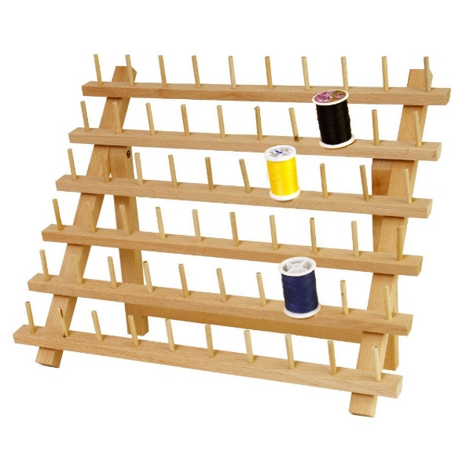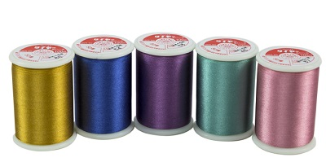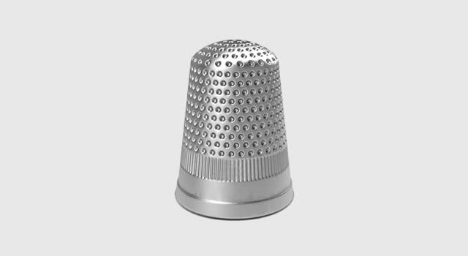

**Thread Rack –** Rack that is used for holding spools of thread.

**Thimble –** Used to protect your fingers when hand sewing.

**Thread –** Fine cord of a fibrous material, such as cotton or flax, made of two or more filaments twisted together and used in needlework and the weaving of cloth.